PAAET’s Commitment to Fair Employment and Compensation
The Public Authority for Applied Education and Training (PAAET) ensures that all employment and compensation practices uphold the highest standards of fairness, transparency, and equality.
As a state institution, PAAET strictly follows the Kuwait Civil Service Commission (CSC) Unified Pay Scale, which guarantees equitable compensation and eliminates discrimination in salary or benefits across all national public entities.
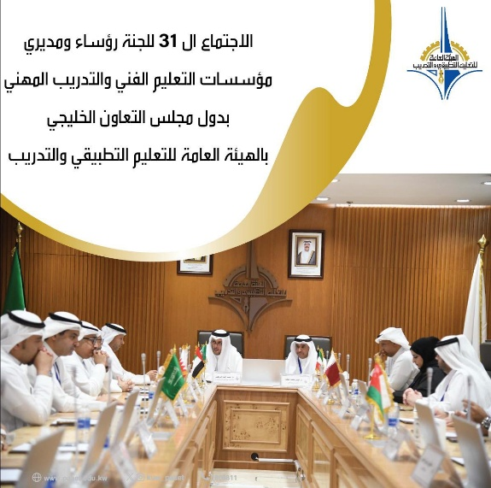

PAAET leadership meeting with GCC technical education directors to review institutional governance and employment frameworks in alignment with Kuwait’s Civil Service Commission and SDG 8 goals.

Equity, Transparency, and Accountability
PAAET’s employment framework reflects the principles of Kuwait Vision 2035 – “New Kuwait”, emphasizing inclusive human capital development and decent work for all.
The Authority’s Human Resources Department applies standardized recruitment, evaluation, and compensation mechanisms that align with national policies and the Civil Service Law No. 15 of 1979 and its executive decrees.
All employment and compensation practices are supervised by the Deputy Director General for Administrative Affairs and Finance, ensuring consistency, accountability, and continuous improvement across all campuses and administrative units.
The “Professional Performance and Conduct System” issued by the State Audit Bureau aims to promote work ethics and professional accountability across all sectors of PAAET.

Institutional Oversight and Salary Framework
PAAET’s employment and compensation practices are governed by the Civil Service Council’s official resolutions, which ensure transparency and fairness across all teaching and training positions.
In accordance with the Council’s 2007 directive, salary grades, teaching allowances, and housing benefits are standardized for all faculty and trainers under the unified public service scale.
This framework guarantees equal pay for equal work, safeguards employee rights, and aligns with Kuwait’s national legislation on fair employment practices.
These measures collectively reinforce PAAET’s compliance with SDG Target 8.5 by ensuring inclusive and equitable compensation structures.

Evidence of Compliance and Oversight
In 2024, PAAET completed a comprehensive compensation compliance review with the Civil Service Commission, confirming 100% adherence to the Unified Pay Scale and minimum-wage regulations.
The audit covered over 5,200 employees across all academic and administrative units.
These findings reaffirm that PAAET’s pay and employment systems are fully compliant with Kuwait’s labor and civil service laws and directly support the United Nations Sustainable Development Goal 8: Decent Work and Economic Growth.
The Financial Regulation, Part I (Teaching and Training Allowances), defines clear procedures for compensation, eligibility, and performance-based incentives for faculty and training staff. This ensures transparency and equity in pay, consistent with the Civil Service Commission’s unified pay scale and Kuwait’s labor laws.

Continuous Improvement and Ethical Leadership
PAAET continuously refines its employment practices by benchmarking compensation policies, gender equity standards, and labor rights indicators against international frameworks such as the ILO Decent Work Agenda.
Beginning in 2025, PAAET will publish an Annual Compensation Transparency Report, providing aggregated data on employee pay, gender balance, and career progression, strengthening institutional accountability and public trust.
These measures directly advance SDG Target 8.5 by ensuring equal pay for work of equal value and eliminating discrimination in employment.

