Education Beyond the Campus
The Public Authority for Applied Education and Training (PAAET) believes that learning should never be limited to classrooms. Through its Continuing Education Center, Office of Community Service, and partnerships with local and international NGOs, PAAET delivers educational programs that reach alumni, residents, and vulnerable populations across Kuwait.
These initiatives embody the university’s civic mission and directly advance the Sustainable Development Goals (SDGs) by promoting inclusion, skills development, and social resilience.

Lifelong Learning for Alumni and the Public
PAAET’s Continuing Education Center (CEC) serves as Kuwait’s gateway for lifelong learning.
It offers an annual catalog of non-credit workshops, certificates, and short courses in:
- Professional skills – digital marketing, project management, data analytics.
- Life skills – financial literacy, communication, and cybersecurity awareness.
- Personal enrichment – language learning, arts, and cultural appreciation.
These programs keep alumni connected to the university and provide all citizens with opportunities for continuous personal and professional growth, directly supporting SDG 4: Quality Education.

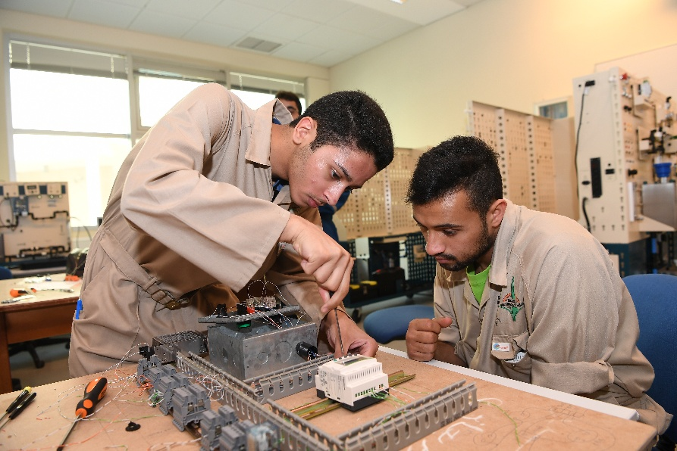

PAAET students develop applied engineering skills through practical workshops that connect education with labor market needs.

Health, Civic, and Environmental Education
In cooperation with the College of Health Sciences and the Ministry of Health, PAAET organizes free public campaigns and workshops focused on community wellness, covering topics such as diabetes prevention, maternal health, and first-aid/CPR training.
Additional outreach events promote environmental conservation and civic responsibility, including hands-on activities in waste management, water conservation, and road safety.
These initiatives build awareness of SDGs 3, 6, 12, and 13, empowering citizens to live healthier and more sustainable lives.

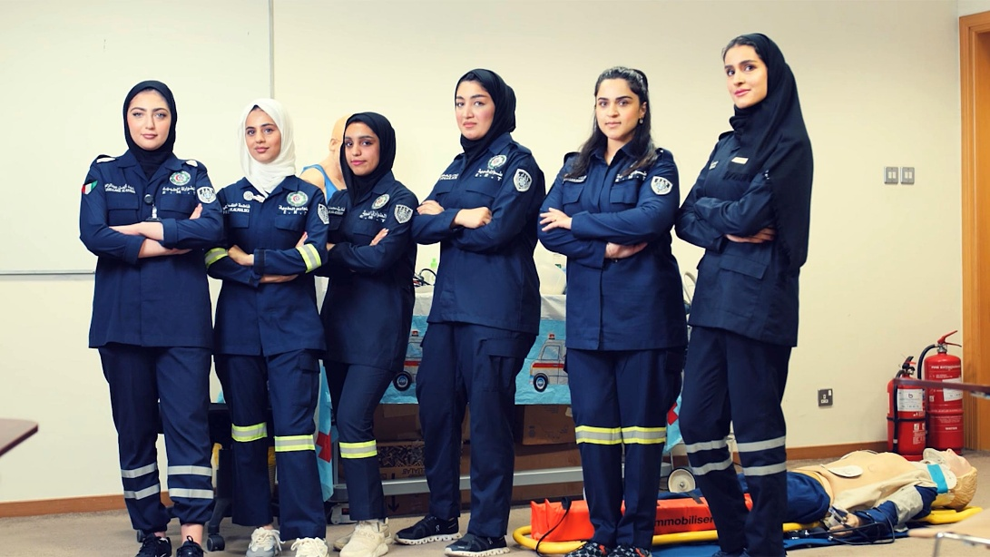

PAAET students in emergency response programs embody collaboration with national health and civic institutions for community well-being.

Inclusive Education for Vulnerable and Displaced Populations
In partnership with humanitarian organizations and educational NGOs, PAAET offers Arabic language instruction, vocational skills workshops, and psychosocial education for displaced and vulnerable groups.
Programs teach practical skills, such as sewing, computer literacy, and small-business management, helping participants achieve economic independence and social integration.
This inclusive model strengthens SDG 10: Reduced Inequalities, ensuring no one is left behind in Kuwait’s development.

Collaborative Networks for Sustainable Impact
PAAET’s outreach success is built on strong collaborations with:
- Kuwait Environment Protection Society
- Kuwait Food Bank
- Kuwait Red Crescent Society
- Local municipalities, schools, and health centers
Together, these partnerships create a nationwide network for lifelong learning, volunteer engagement, and sustainable community development, illustrating the essence of SDG 17: Partnerships for the Goals.
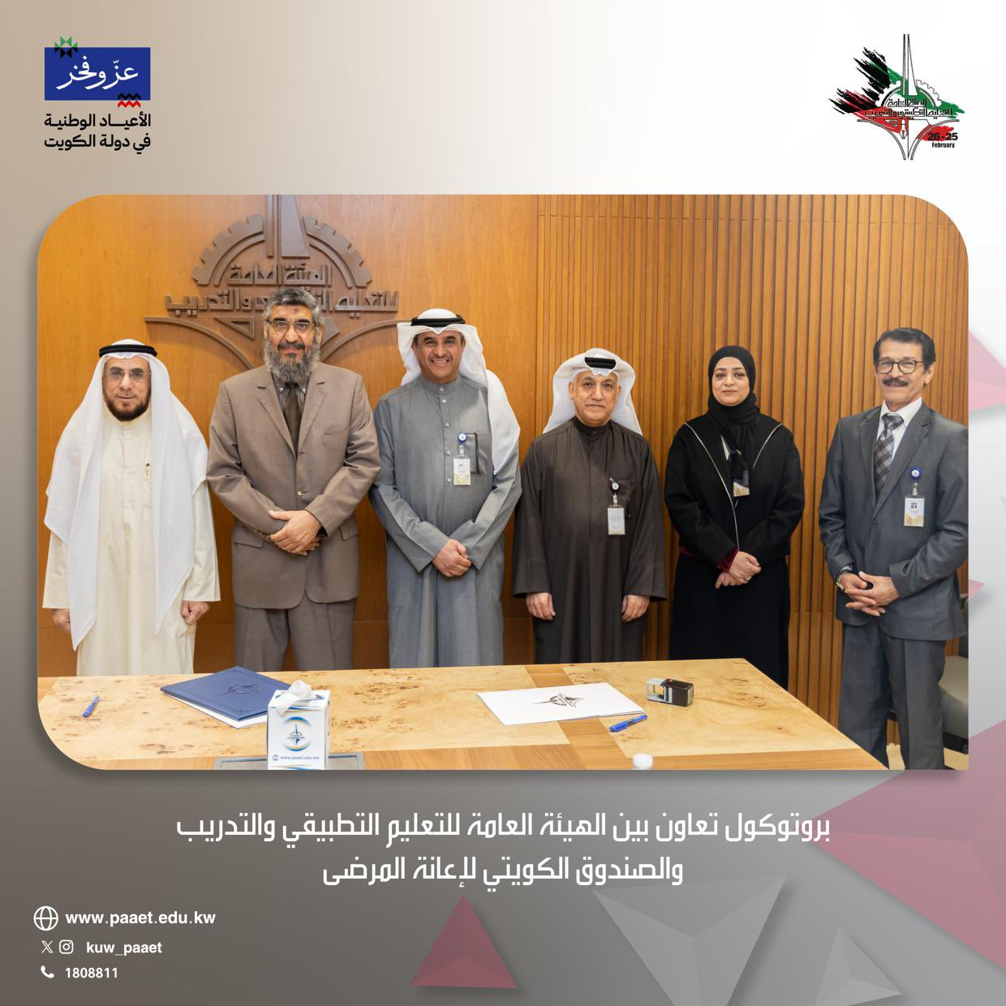

Cooperation Protocol between the Public Authority for Applied Education and Training (PAAET) and the Kuwait Patient Aid Society.

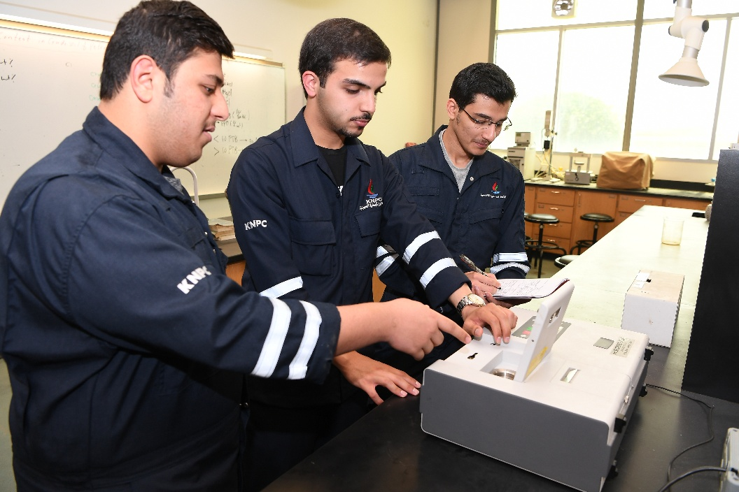

PAAET students train with the Kuwait National Petroleum Company, reinforcing education–industry partnerships that drive national sustainability goals.

Looking Ahead
To expand its community impact, PAAET is developing a digital “Community Campus” portal to offer free online courses and resources, alongside a micro-credentialing system that formally recognizes learning achievements.
These innovations will make continuing education more accessible, measurable, and inclusive across Kuwait.

Conclusion
Through its comprehensive outreach framework, the Public Authority for Applied Education and Training extends the power of education to every member of society.
By connecting academic expertise with community needs, PAAET transforms learning into lifelong empowerment, advancing Kuwait’s progress toward the UN 2030 Agenda and strengthening its role as a national partner for sustainable development.

