Upholding Human Dignity in Every Aspect of Work
The Public Authority for Applied Education and Training (PAAET) upholds an unwavering commitment to human dignity, justice, and ethical employment.
We believe that educational and institutional excellence are inseparable from respect for fundamental human rights.
In alignment with Kuwait’s labor and anti-trafficking laws, and the United Nations Sustainable Development Goals, PAAET enforces a comprehensive policy framework that prohibits all forms of forced labor, human trafficking, child labor, and modern slavery within its workforce, operations, and supply chain.
This policy reinforces Kuwait’s social values and directly supports SDG 8 – Decent Work and Economic Growth.

Zero-Tolerance Policy in Institutional Governance
PAAET’s Code of Ethical Conduct articulates a clear zero-tolerance stance toward all forms of labor exploitation.
“PAAET has zero tolerance for forced, compulsory, or child labor in all its operations and expects the same ethical standard from its partners and suppliers.”
This commitment is embedded across the institution, from academic and administrative recruitment to procurement and external partnerships, ensuring that every stakeholder operates under the same ethical standard.
It applies equally to faculty, staff, and contractors, making ethical conduct a shared responsibility across the organization.
PAAET’s Code of Conduct clearly defines zero tolerance for any form of forced, compulsory, or exploitative labor. It guides all employees and contractors in upholding integrity, fairness, and respect for human dignity

Aligned with Kuwait’s Legal Framework
PAAET’s policy framework is fully grounded in Kuwait’s strong legal protections, including:
- Law No. 91/2013 on Combating Human Trafficking, which criminalizes all forms of labor exploitation and trafficking.
- Labor Law No. 6/2010, which establishes minimum age limits and protects workers from coercion, discrimination, or exploitative employment practices.
Together, these national laws, reinforced by PAAET’s internal governance, create a dual-layer protection system that safeguards employees’ rights and promotes ethical compliance at every level.

Ethical Procurement and Supply Chain Oversight
PAAET recognizes that ethical responsibility extends beyond the campus.
Our Procurement Guidelines require all vendors and suppliers to comply with Kuwait’s labor laws and international human-rights standards.
Every supplier contract includes clauses mandating adherence to fair employment practices and zero tolerance for forced or child labor.
This approach ensures that PAAET’s ethical values extend across its entire supply chain, promoting transparency, accountability, and human dignity.

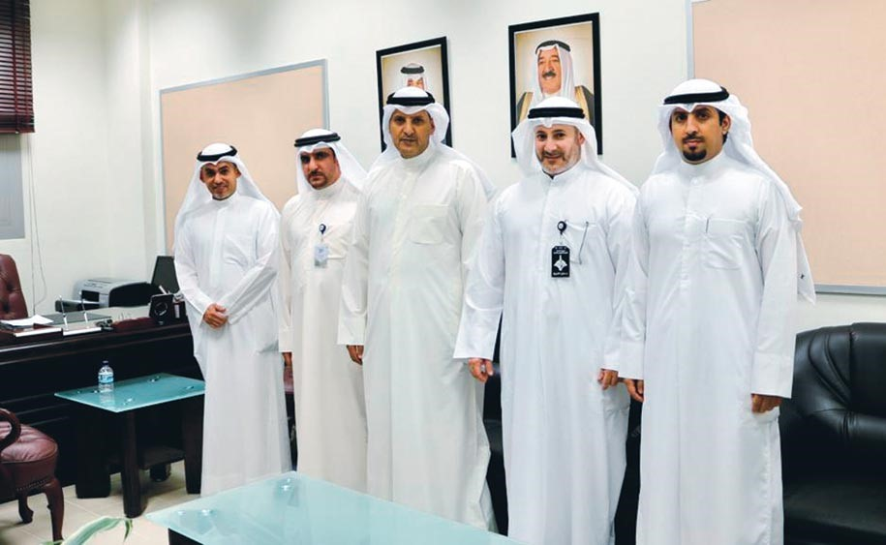

The Public Authority for Manpower visits PAAET to follow up on the Labor Inspectors Training Program, reinforcing Kuwait’s national framework for ethical employment.

Awareness, Prevention, and Reporting Mechanisms
PAAET transforms policy into daily practice through continuous awareness, education, and accountability mechanisms:
- Mandatory Ethics Training for new employees, faculty, and contractors.
- Regular Awareness Campaigns on labor rights, workplace integrity, and ethical conduct.
- Confidential Reporting Channels managed by the Human Resources Department, allowing safe reporting of any suspected violations.
Through these initiatives, the Authority fosters a culture of vigilance and shared responsibility.
Kuwait’s legislation reinforces the prevention of forced labor and unethical employment practices through Articles 9, 10, 14, and 29, which mandate training, awareness, and humane treatment of all workers, including migrant and contracted staff. In line with these national provisions, PAAET integrates human-rights-based education, ethical recruitment standards, and monitoring systems across its employment and procurement procedures. Specialized workshops and staff orientations emphasize dignity at work and compliance with international labor standards, directly advancing SDG Target 8.7.

Continuous Improvement and Global Alignment
PAAET continues to enhance its ethical employment standards by:
- Collaborating with the Ministry of Social Affairs and Labor to align institutional practices with evolving regulations.
- Benchmarking against international frameworks such as the ILO Protocol of 2014 and the UN Guiding Principles on Business and Human Rights.
- Conducting supply-chain audits and specialized training workshops for procurement and compliance teams.
These efforts underscore PAAET’s leadership in ethical governance and its ambition to become a regional model for responsible employment.



PAAET signed a cooperation agreement with the Kuwait National Guard to provide technical training and skill-development programs, supporting youth employability and national workforce readiness (SDG 8.2.4).

Conclusion
The Public Authority for Applied Education and Training enforces a firm, explicit, and enforceable stance against forced labor, modern slavery, human trafficking, and child labor.
Through clear policies, legal alignment, transparent procurement, and active awareness programs, PAAET protects every individual connected to its institution.
This holistic framework reflects Kuwait’s national vision of justice and equality, ensuring that PAAET’s growth is built on ethical integrity, human dignity, and sustainable development, the very essence of SDG 8 – Decent Work and Economic Growth.

