Driving Dialogue Across Sectors
The Public Authority for Applied Education and Training (PAAET) plays a pioneering role in building Kuwait’s national dialogue on sustainable development.
Through its convening power and reputation for applied expertise, PAAET brings together leaders from government, academia, civil society, and industry to exchange knowledge, co-create solutions, and accelerate progress toward the Sustainable Development Goals (SDGs).
Since 2021, PAAET has served as a trusted platform for connecting diverse stakeholders under Kuwait Vision 2035, transforming its campuses into spaces for innovation, inclusion, and impactful collaboration.

Initiating Transformative Partnerships
PAAET proactively designs and hosts high-impact forums that bridge institutional boundaries.
Its Annual SDG Dialogue Forum, launched in 2021, gathers representatives from ministries, NGOs, and private companies to discuss national challenges such as quality education (SDG 4), food security (SDG 2), and renewable energy (SDG 7).
Each year, this flagship event produces concrete outcomes, joint initiatives, memoranda of understanding, and policy recommendations that feed directly into Kuwait’s sustainable development agenda.
In addition, PAAET’s colleges host specialized multi-stakeholder workshops:
- The College of Health Sciences collaborates with the Ministry of Health and NGOs on public-health dialogues such as Diabetes Prevention Strategies in Kuwait.
- The College of Technological Studies partners with the Ministry of Electricity & Water and private engineering firms to address renewable-energy integration and environmental innovation.

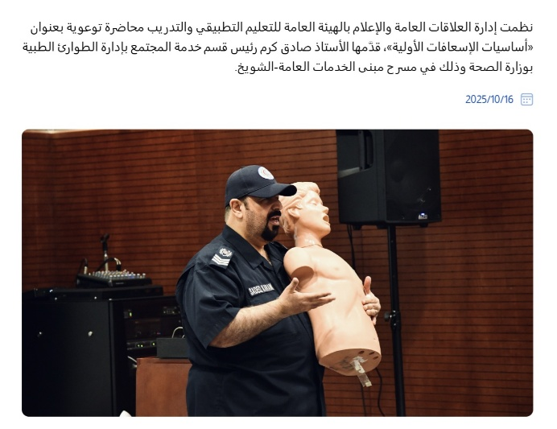

A lecture on first aid was delivered by Chief Sadiq Karam from the Ministry of Health, organized by the Public Relations and Media Department at the Public Authority for Applied Education and Training (PAAET).

Active Participation in National and Regional Platforms
Beyond initiating its own forums, PAAET is a regular contributor to national and regional SDG platforms organized by the Supreme Council for Planning and Development (SCPD), KFAS, and other leading organizations.
Faculty members and senior leaders frequently participate as keynote speakers, expert panelists, and moderators, ensuring that research insights and applied experience inform decision-making at all levels.
This active participation enhances Kuwait’s collective capacity to align research, education, and policy implementation with the UN 2030 Agenda.
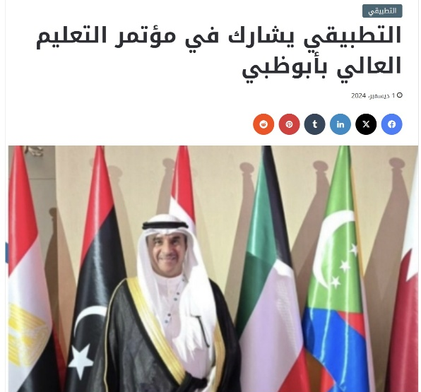

PAAET participates in the Arab Conference on Higher Education in Abu Dhabi, strengthening regional cooperation and knowledge exchange among Arab states in alignment with SDG 17.

Fostering Trust and Collaboration
As a neutral academic convener, PAAET provides a “safe space” where government officials, private executives, academics, and civil-society actors can engage in open, evidence-based discussions.
These interactions foster trust, strengthen inter-institutional networks, and lay the groundwork for sustained cooperation on long-term sustainability projects.
By breaking traditional silos, PAAET’s forums encourage joint ownership of solutions — ensuring that national progress on the SDGs is inclusive, participatory, and future-focused.

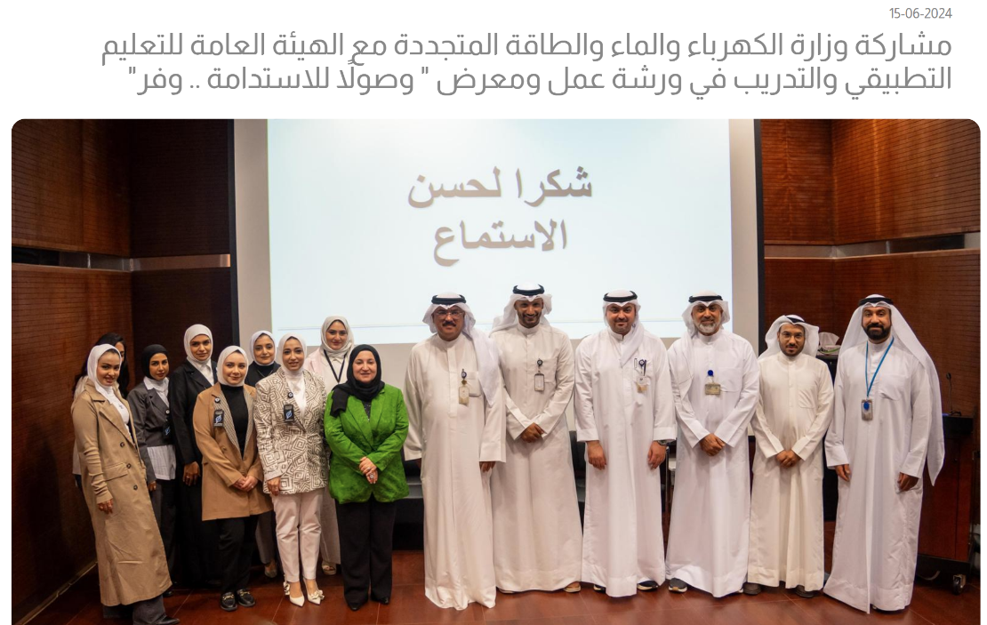

The Ministry of Electricity, Water and Renewable Energy collaborated with the Public Authority for Applied Education and Training (PAAET) in a workshop on sustainability.

Empowering the Next Generation
PAAET actively involves its students and young researchers in these dialogues as rapporteurs, presenters, and facilitators.
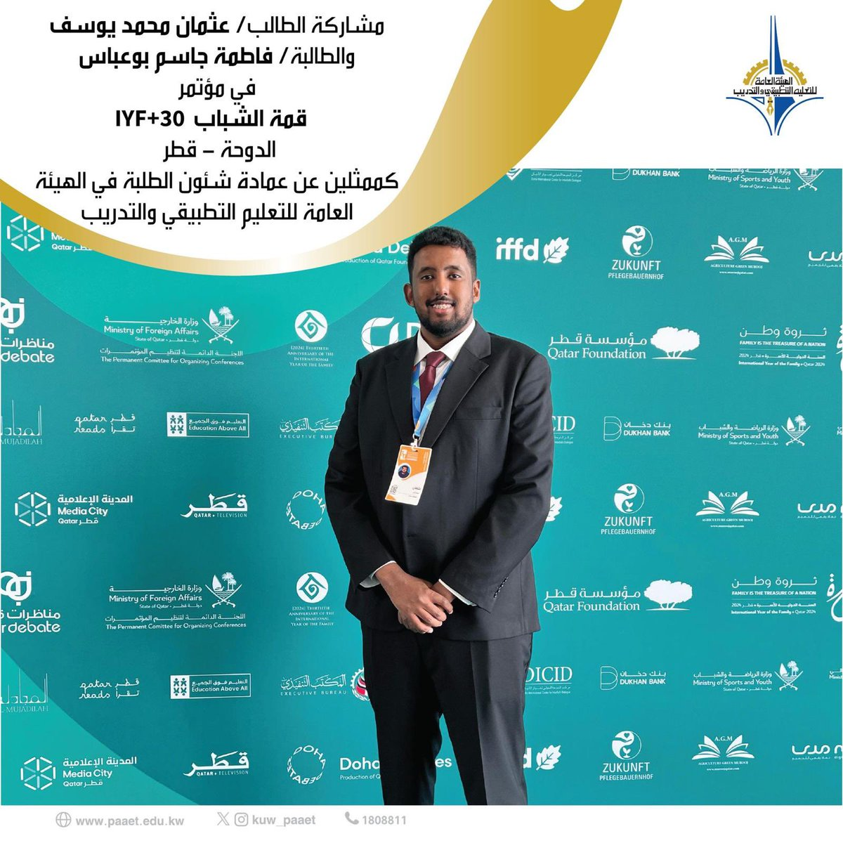

PAAET student Othman Yousif participated in the Youth Summit in Doha as PAAET representative.
This experiential learning cultivates leadership, strengthens civic engagement, and empowers youth to contribute meaningfully to Kuwait’s sustainability transformation. From 2021 to 2024, PAAET organized more than 15 multi-stakeholder forums and workshops, engaging over 900 participants from public, private, and non-profit sectors.

Looking Ahead
Building on its success, PAAET plans to:
- Launch a Digital SDG Dialogue Portal – an online platform archiving presentations, proceedings, and policy recommendations for public access.
- Establish SDG Consortia – thematic, action-oriented groups linking academia, government, and industry to implement collaborative solutions.
- Enhance Student Integration – creating formal roles for student participation in policy dialogue and knowledge exchange.

Conclusion
Through its leadership in fostering inclusive, cross-sectoral partnerships, the Public Authority for Applied Education and Training exemplifies the power of education to unite sectors for a common purpose.
By transforming dialogue into joint action, PAAET reinforces Kuwait’s commitment to sustainable development and positions itself as a model institution for SDG 17, Partnerships for the Goals.

