Advancing Knowledge Through Global Data Partnerships
The Public Authority for Applied Education and Training (PAAET) plays a vital role in connecting Kuwait to the global Sustainable Development Goals (SDGs) data network.
Through international collaborations in health, environment, and engineering, PAAET contributes high-quality data that informs global research, strengthens regional understanding, and ensures Kuwait’s realities are represented in international indicators.
By linking its applied research expertise with global scientific networks, PAAET transforms local data into global insight, helping the world to measure what matters most.
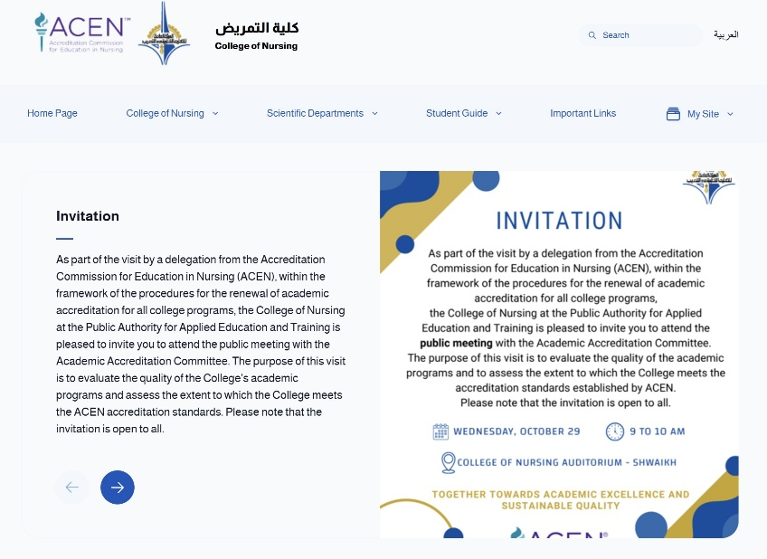

Advancing Knowledge Through Global Partnerships – The College of Nursing at PAAET hosts a delegation from the Accreditation Commission for Education in Nursing (ACEN) to evaluate academic programs, strengthen international accreditation standards, and promote sustainable quality in education.

Contributing to Global Health Data (SDG 3)
PAAET’s College of Health Sciences collaborates closely with the Ministry of Health on national research and public health initiatives, including major epidemiological studies. Through these joint projects, PAAET collects and analyzes national data on non-communicable diseases such as diabetes and cardiovascular conditions, following the Ministry’s standardized health research protocols. This partnership strengthens Kuwait’s national health database, supports evidence-based policymaking, and enhances the quality and reliability of health indicators at both national and regional levels.
Regional Environmental Monitoring (SDGs 6, 13, 14)
In partnership with regional universities and environmental research organizations, PAAET participates in cross-border monitoring of marine and coastal ecosystems.
These initiatives involve:
- Collecting data on marine pollution, biodiversity, and water quality.
- Standardizing methodologies for environmental measurement across Gulf states.
- Contributing findings to regional SDG reports that guide sustainable management of shared natural resources.
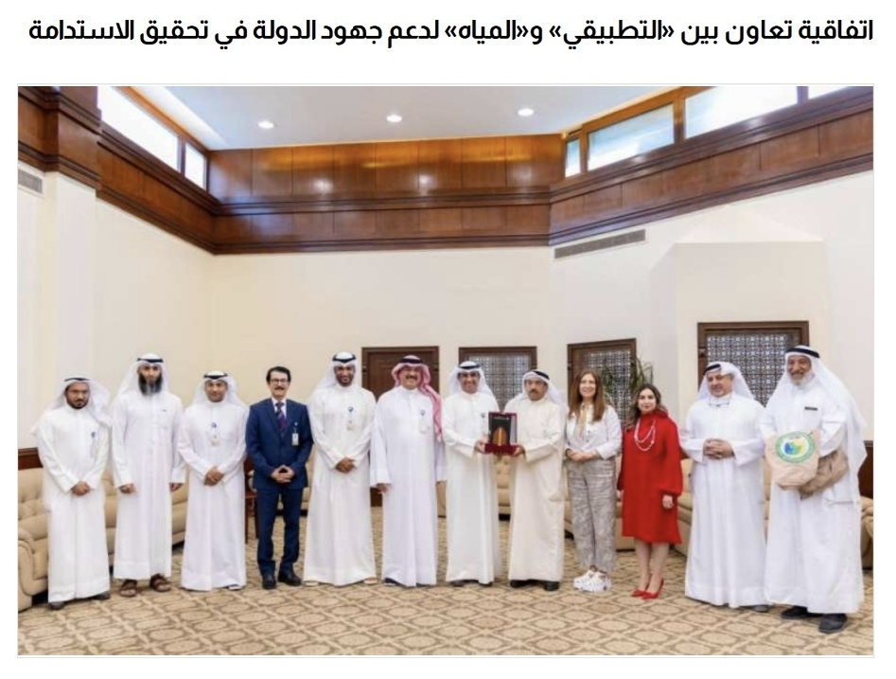
Through these collaborations, PAAET helps track environmental trends and inform strategies for clean water (SDG 6), climate action (SDG 13), and life below water (SDG 14).

PAAET and the Kuwait Water Association have signed a cooperation agreement to support the state's efforts in achieving water sustainability and developing relevant academic programs for graduates.

Building Capacity Through Data Collaboration
PAAET’s participation in international data projects provides its researchers and students with exposure to global best practices in data science, epidemiology, and environmental engineering.
This not only enhances Kuwait’s scientific capabilities but also builds national capacity for SDG reporting, monitoring, and evaluation.
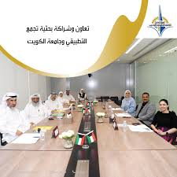
Through shared methodologies and peer collaboration, PAAET ensures that its research meets global standards, contributing to a more credible and comparable international data ecosystem.

Research Collaboration and Partnership between Kuwait University and the Public Authority for Applied Education and Training (PAAET)

From Local Evidence to Global Insight
PAAET’s role as both a data producer and a knowledge partner bridges the gap between local realities and global frameworks.
By sharing data responsibly and ethically, the Authority ensures that the Kuwaiti context is represented in global datasets, enriching the understanding of sustainability challenges in arid, oil-producing nations.
This approach aligns perfectly with Kuwait Vision 2035 and reinforces the nation’s leadership in regional scientific cooperation.
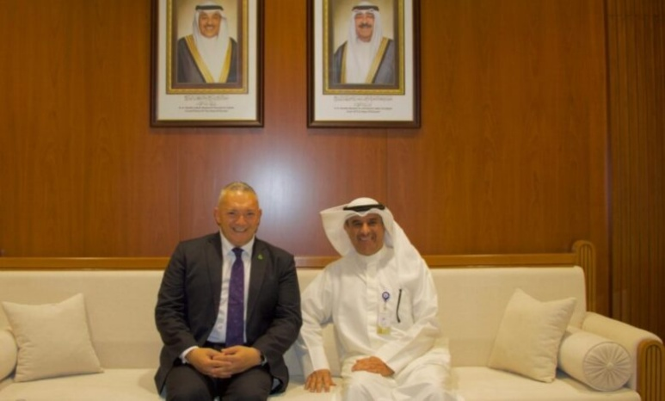

The Director General of PAAET meets with officials from the New Zealand Ministry of Education to discuss opportunities for academic cooperation, vocational training exchange, and the advancement of applied education.

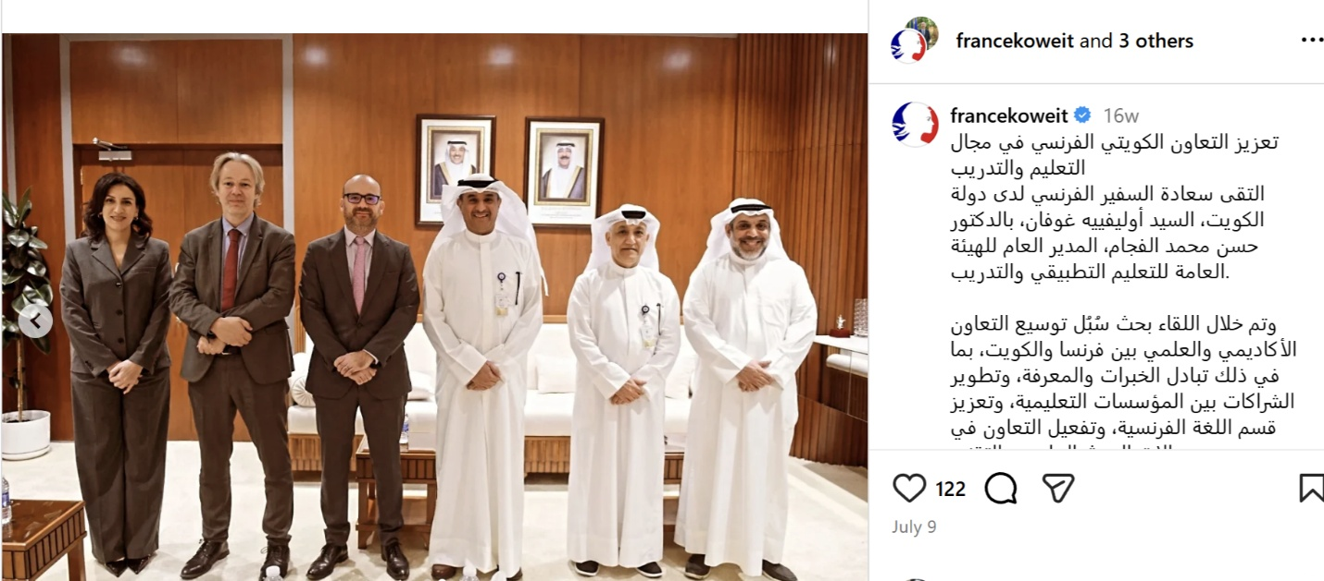
PAAET leadership met with the French Ambassador to Kuwait to strengthen academic and training cooperation, promoting knowledge exchange and international partnerships in line with SDG 17.

Looking Ahead
To expand its global data collaboration, PAAET aims to:
- Establish a Central SDG Data Office to coordinate data-sharing partnerships and ensure data security and ethical compliance.
- Take leadership roles in regional SDG data networks, particularly in water security, environmental monitoring, and health surveillance.
- Launch an Open-Access SDG Data Portal to make non-sensitive research outputs publicly available, supporting transparency and global scientific exchange.
The Public Authority for Applied Education and Training (PAAET) Institutional Report provides a comprehensive overview of its local and international partnerships, SDG-aligned initiatives, and capacity-building programs that strengthen technical and vocational education in Kuwait.
[Download the full report – PAAET: Advancing Technical Education for Sustainable Development]

Conclusion
PAAET’s engagement in international SDG data collaborations highlights its dual commitment, advancing global sustainability science while strengthening Kuwait’s research excellence.
By contributing accurate, standardized, and locally grounded data to international partnerships, PAAET continues to play a key role in helping the world track progress toward the UN 2030 Agenda.

