Policy Partnerships for National SDG Implementation
The Public Authority for Applied Education and Training (PAAET) plays a strategic role in advancing Kuwait’s national efforts to achieve the United Nations Sustainable Development Goals (SDGs) through strong institutional partnerships with government, academia, and civil society.
Under the leadership of the Directorate of Planning and Development, PAAET contributes directly to Kuwait’s national SDG framework by providing research, data analysis, and policy recommendations that inform government strategies. The Authority actively collaborates with the Supreme Council for Planning and Development (SCPD), the Kuwait Foundation for the Advancement of Sciences (KFAS), and other national agencies to align education, training, and workforce development with Kuwait Vision 2035 and the SDGs.
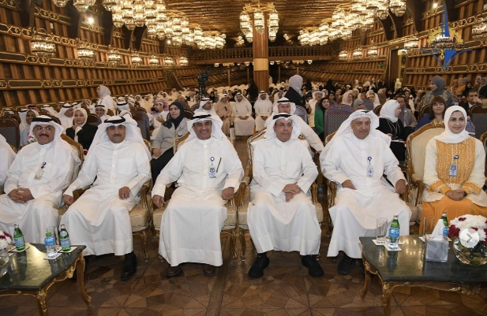

The First International Conference on Practical Education – Sustainable Educational Development in Light of Kuwait Vision 2030

National Participation in Achieving Global Goals
Between 2022 and 2024, PAAET participated in national SDG coordination committees, contributed to the preparation of Kuwait’s Voluntary National Review (VNR), and engaged in policy-modelling workshops focused on SDG 4 (Quality Education), SDG 8 (Decent Work and Economic Growth), and SDG 17 (Partnerships for the Goals). These engagements highlight PAAET’s growing influence as a knowledge partner in shaping sustainable national policies.

Through its Continuing Education Center (CEC), PAAET also strengthens the capacity of public-sector professionals by offering training programs on sustainable development, data-driven planning, and institutional performance management. More than 500 civil servants have been trained in SDG-related competencies, helping embed sustainability principles within Kuwait’s government institutions.

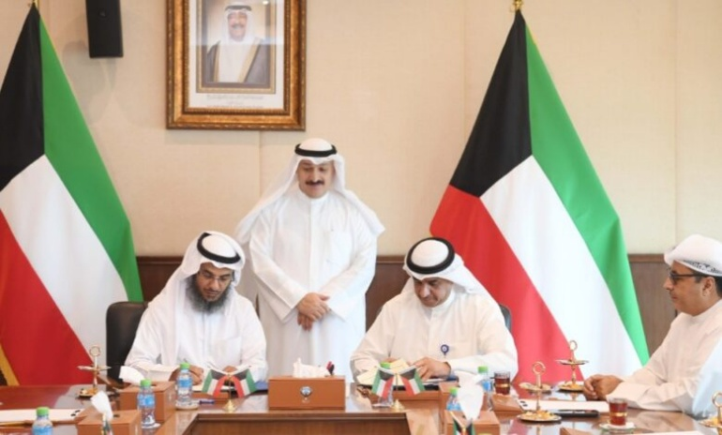

The general director, Dr. Hassan Alfajjam signed a protocol of cooperation with the Ministry of Health

PAAET represented the State of Kuwait at the 43rd Session of UNESCO’s General Conference held in Uzbekistan. The participation reflected the Authority’s active role in international educational dialogue, contributing to global policies on quality education, technical training, and sustainable development. This engagement underscores PAAET’s commitment to SDG 17: Partnerships for the Goals, and SDG 4: Quality Education.
All partnership activities are guided by the National Partnerships and Policy Advisory Framework (2023), which ensures coordination, accountability, and transparency across projects. The framework guarantees that every collaboration with government or community organizations is directly aligned with national development priorities and global sustainability standards.
By bridging education, research, and policy, PAAET demonstrates its commitment to transforming knowledge into real-world impact and supporting Kuwait’s leadership in sustainable development across the Gulf region.

