From Education to Impact
The Public Authority for Applied Education and Training (PAAET) is committed not only to teaching sustainability, but also to measuring how effectively students learn it.
Through a structured framework of assessment and evaluation, PAAET ensures its graduates possess the knowledge, skills, and values required to address real-world sustainability challenges aligned with the UN Sustainable Development Goals (SDGs).
By embedding sustainability literacy measurement into its academic system, PAAET demonstrates that education for sustainable development must be both intentional and accountable.

1. Direct Learning Assessment – Integration of Sustainability in Core Courses
Although PAAET does not offer a standalone course titled “PAAET 101: Sustainable Futures”, the concept of sustainability is embedded across many core courses offered in its colleges. These courses include learning outcomes and assessments that evaluate students’ understanding of sustainability principles and the UN Sustainable Development Goals (SDGs).
Students are assessed on their:
- Knowledge of global and local sustainability challenges.
- Awareness of the interconnections among the SDGs.
- Ability to apply sustainability principles within the Kuwaiti context.
This integrated approach enables PAAET to monitor students’ progress and literacy in sustainability through course-based evaluations, providing measurable evidence of learning impact across disciplines.

2. Applied Competency in Professional Programs
PAAET embeds sustainability outcomes into program-level assessments across disciplines:
- Engineering students are evaluated on environmental impact and sustainable design within capstone projects.
- Nursing and health sciences students apply sustainable healthcare practices and assess social determinants of health (SDG 3).
- Technology and business students integrate sustainability solutions into community-based projects.
By assessing students’ ability to apply sustainability in their field, PAAET ensures that sustainability literacy is a professional skill, not merely a theoretical concept.
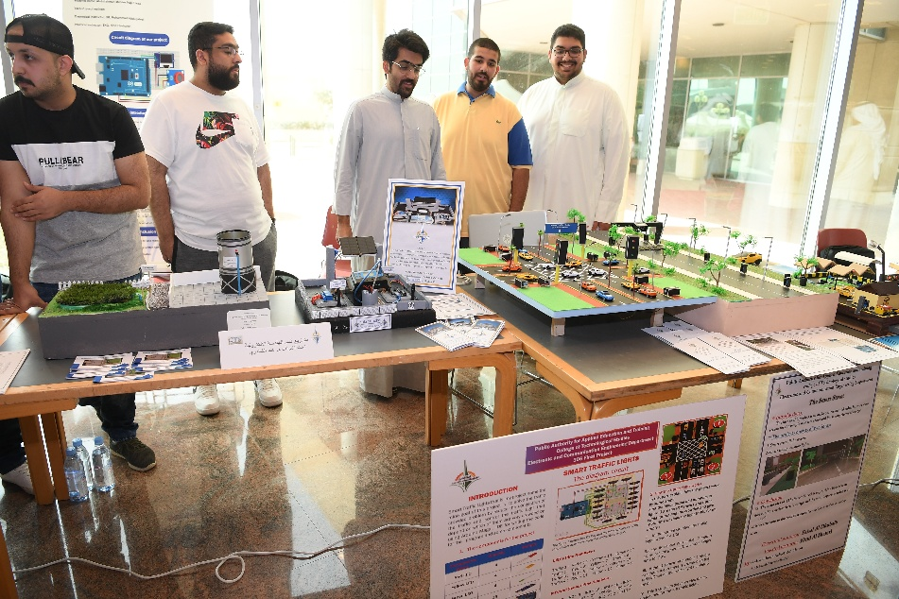

Engineering graduation project showcasing sustainable design principles and clean energy applications.

3. Tracking Long-Term Graduate Impact
PAAET’s commitment to sustainable education extends beyond graduation through a comprehensive Graduate Tracer Study, which measures how graduates apply sustainability principles in their professional and personal lives. The Authority has also established a dedicated department responsible for following up with graduates, collecting and analyzing data, and producing reports that support the continuous improvement of academic and training programs in line with labor market needs.
This study provides both quantitative and qualitative insights that enhance ongoing curriculum development and demonstrate the long-term impact of sustainability education on graduates and their institutions.

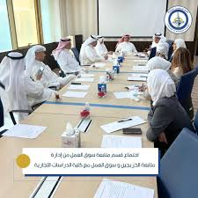

A meeting of the Labor Market Follow-up Department at the College of Business Studies to discuss cooperation and strengthen engagement between PAAET and the national labor market.

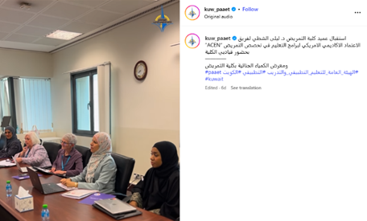

PAAET’s College of Nursing hosted a delegation from the Accreditation Commission for Education in Nursing (ACEN) to review its programs and enhance international accreditation standards.

A Data-Driven Approach to Education for Sustainable Development
PAAET’s sustainability literacy assessment framework exemplifies accountability in higher education.
By integrating course-based assessments, applied program evaluations, and graduate feedback, the Authority closes the loop between teaching, learning, and measurable outcomes.
This system enables PAAET to identify gaps, refine programs, and enhance its contribution to national and global sustainability goals.
All outreach and lifelong learning activities are coordinated under the Deputy Director General for Academic Affairs and Community Engagement to ensure alignment with PAAET’s strategic SDG plan.
Between 2023 and 2024, more than 2,000 participants benefited from PAAET’s community education and health awareness programs across Kuwait.

Looking Ahead
PAAET is advancing its assessment ecosystem through initiatives to:
- Set a university-wide sustainability literacy benchmark for all graduates.
- Launch a longitudinal student study tracking learning progress from enrollment to employment.
- Benchmark results against international peers to ensure alignment with global best practices in sustainability education.
Through these steps, PAAET continues to strengthen its role as a regional leader in applied sustainability education and a catalyst for responsible societal transformation.

Conclusion
PAAET’s comprehensive approach to measuring sustainability literacy ensures that every graduate leaves not only with a qualification but with the capacity to build a more sustainable Kuwait.
By aligning educational outcomes with measurable competencies, PAAET transforms the principles of the SDGs into lifelong professional and personal practice.

