Empowering Communities Through Collaboration
The Public Authority for Applied Education and Training (PAAET) has built a strong, strategic network of partnerships with non-governmental organizations (NGOs) to translate academic knowledge into real-world impact.
By connecting education, research, and civic action, PAAET’s collaboration model ensures that every initiative, whether student volunteering, applied research, or curriculum development, directly supports the Sustainable Development Goals (SDGs) and advances Kuwait Vision 2035.
Through these partnerships, PAAET positions itself as a bridge between academia and civil society, fostering collective solutions for national and global challenges.
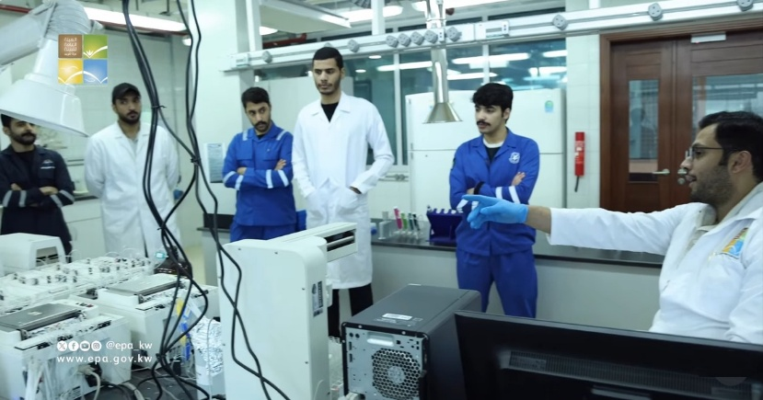

As part of ongoing cooperation between educational institutions, the Environment Public Authority hosted PAAET students for field training at the Chemical Testing Laboratories to enhance their practical and applied skills for future careers.

Student Volunteering Programs – Civic Engagement in Action
PAAET’s formal agreements with organizations such as the Kuwait Environment Protection Society and the Kuwait Food Bank create structured, credit-bearing service-learning opportunities.
Students participate in projects including:
- Planting and ecosystem restoration (SDG 13, 15)
- Food security and distribution initiatives (SDG 2)
- Digital literacy training for senior citizens (SDG 4)
In addition, specialized student groups like the PAAET Health Ambassadors collaborate with NGOs to conduct free health screenings, wellness campaigns, and community health workshops, linking classroom learning with service to society.
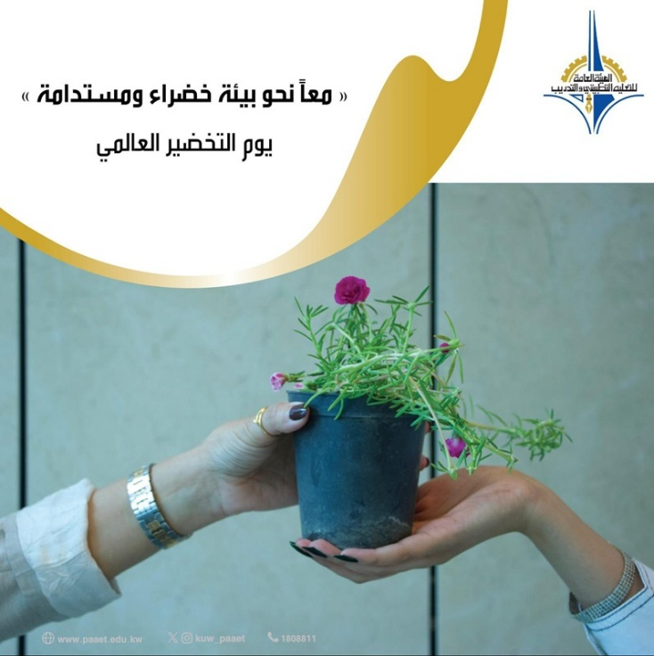

PAAET promotes environmental awareness through partnerships with NGOs and community groups, inspiring collective action for a greener, more sustainable future.

Joint University-NGO Research Programs
PAAET integrates community-based participatory research (CBPR) into its academic frameworks, ensuring that research addresses genuine social needs.
- The College of Health Sciences collaborates with patient-advocacy organizations on studies addressing chronic-disease management and mental-health support (SDG 3).
- Faculty from education and social science disciplines partner with NGOs focused on equity and inclusion to study access to education for students with disabilities (SDG 10).
The evidence produced empowers NGOs to design data-driven campaigns and advocate for policy reform—turning academic findings into community impact.

Co-Developing Educational Resources for Schools and Society
PAAET’s College of Basic Education works with educational NGOs to co-create open educational resources (OER) aligned with Kuwait’s national curriculum.
These resources include lesson plans, multimedia modules, and interactive activities promoting:
- Water conservation (SDG 6)
- Responsible consumption (SDG 12)
- Environmental stewardship and citizenship (SDG 4.7)
PAAET students in media and communications also collaborate with environmental NGOs to produce public-awareness videos and campaigns addressing plastic pollution, recycling, and biodiversity loss, strengthening environmental literacy nationwide.
The Public Authority for Applied Education and Training (PAAET) Institutional Report provides a comprehensive overview of its local and international partnerships, SDG-aligned initiatives, and capacity-building programs that strengthen technical and vocational education in Kuwait.
[Download the full report – PAAET: Advancing Technical Education for Sustainable Development]
(Link to the report PDF)

Creating a Comprehensive Partnership Ecosystem
PAAET’s partnership model operates on three integrated pillars:
- Education and Service Learning – Empowering students to serve their communities.
- Applied Research and Innovation – Producing knowledge that solves real-world problems.
- Public Education and Awareness – Engaging society through accessible learning tools and campaigns.
This approach ensures that every partnership amplifies impact—transforming students into active citizens and NGOs into more powerful agents of change.
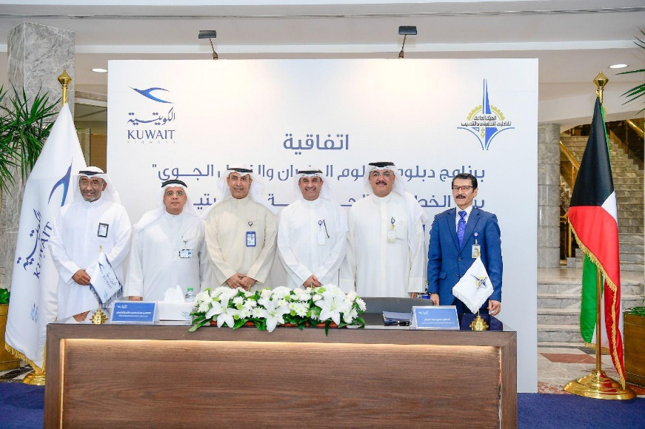

PAAET and Kuwait Airways sign a strategic cooperation agreement to enhance technical training and support national development in alignment with the Sustainable Development Goals (SDG 17 – Partnerships for the Goals).

Looking Ahead
To strengthen and expand its collaborative impact, PAAET plans to:
- Launch a Digital NGO Partnership Portal to connect faculty and students with NGO projects in real time.
- Create an NGO-University SDG Innovation Fund to support co-designed pilot initiatives.
- Publish an Annual Partnership Impact Report with key NGO partners to measure and showcase collective results.
These initiatives will deepen PAAET’s role as a national leader in academia-civil-society collaboration for sustainability.
Conclusion
Through strategic collaboration with NGOs, PAAET translates education into empowerment, research into advocacy, and community service into sustainable progress.
This model demonstrates how partnerships can multiply impact—combining academic expertise with grass-roots action to advance the SDGs and build a stronger, more inclusive Kuwait.

