Commitment to Workers’ Rights and Social Dialogue
At the Public Authority for Applied Education and Training (PAAET), we believe that open communication and respect for workers’ rights are fundamental to institutional excellence and sustainable growth.
Operating within Kuwait’s national labor framework, PAAET fosters social dialogue, ensuring that every employee, Kuwaiti or international, has access to representation, equity, and voice in decision-making.
This commitment directly supports SDG 8: Decent Work and Economic Growth, which emphasizes fairness, equality, and strong labor institutions.

Union Representation for Kuwaiti Staff and Faculty
All Kuwaiti national employees at PAAET, both men and women, enjoy full legal rights to form and join unions as stipulated by Kuwait’s Trade Union Law (No. 28/2023).
PAAET officially recognizes and collaborates with the Kuwaiti General Syndicate of Workers in Government Ministries and Public Bodies, the authorized representative for all Kuwaiti public-sector employees.
Through this framework:
- Staff participate in collective bargaining, policy dialogue, and welfare committees.
- Gender equality is guaranteed: Kuwaiti women have equal rights to vote, run for union office, and hold leadership positions.
- Regular meetings between PAAET and the Syndicate ensure continuous cooperation and mutual trust.
This model demonstrates Kuwait’s strong commitment to equity, inclusion, and social partnership in the public sector.

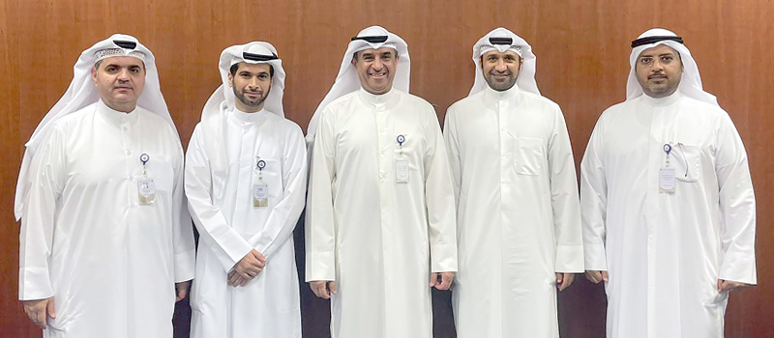

PAAET leadership meets with the Faculty Association to discuss faculty development, welfare policies, and shared governance matters.

Evolving Representation for International Faculty and Staff
PAAET deeply values the contributions of its international workforce.
All non-Kuwaiti employees are protected under the Kuwait Labor Law (No. 6/2010), ensuring fair contracts, legal rights, and grievance protections.
Significant progress has been achieved under Trade Union Law No. 28/2023, which, for the first time, permits non-Kuwaiti employees to join unions, marking an important step toward greater inclusivity.
While this new framework is being fully implemented nationwide, PAAET provides:
- Internal grievance mechanisms managed by the Human Resources Department.
- Orientation and training to ensure expatriate staff are aware of their rights.
- Open-door communication channels that encourage participation, feedback, and dialogue.
These initiatives reaffirm PAAET’s position as a fair, transparent, and inclusive employer.

Inclusive Governance and Continuous Improvement
Beyond compliance, PAAET actively seeks to enhance representation and engagement through:
- Establishing an International Staff Liaison Committee to provide collective input in institutional matters.
- Conducting awareness workshops on labor rights, inclusion, and communication.
- Promoting women’s leadership and cross-cultural collaboration in workplace governance.
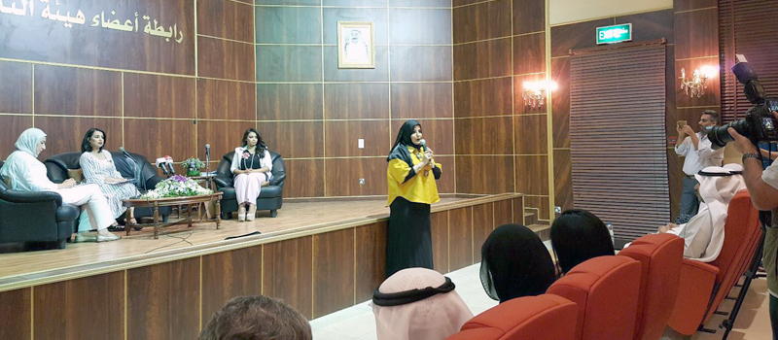

The Women’s Committee of the Faculty Association organized a lecture titled ‘Kuwaiti Women’s Demands: Between Reality and Hope’, highlighting PAAET’s ongoing support for women’s empowerment, leadership, and participation in shaping institutional policies.

Such actions illustrate PAAET’s dedication to fostering a diverse, respectful, and empowered working environment aligned with global best practices.
PAAET’s Strategic Plan 2025–2030 reinforces this commitment by embedding participatory governance and stakeholder dialogue within institutional policy. The plan was developed through six workshops and twenty-seven consultation meetings with more than 2,100 participants representing faculty, trainers, administrators, and students. This inclusive planning model ensures that employee and student perspectives directly inform policy design, demonstrating a culture of open communication and shared decision-making that aligns with SDG 8 objectives on decent work and effective social dialogue.

Alignment with National and Global Goals
PAAET’s labor-relations framework mirrors Kuwait’s constitutional guarantees of equality and advances the principles of the International Labor Organization (ILO) regarding freedom of association and decent work.
Through compliance, inclusivity, and proactive dialogue, the Authority contributes to Kuwait Vision 2035 – New Kuwait, strengthening social cohesion, institutional transparency, and sustainable economic growth.

Conclusion
The Public Authority for Applied Education and Training stands as a model of ethical governance and inclusive labor representation.
It safeguards the rights of its Kuwaiti employees through recognized unions and extends meaningful participation opportunities to its international staff.
By ensuring that every voice at PAAET is heard and respected, the institution reinforces its role as a leader in fair employment, equality, and sustainable development, core values of SDG 8: Decent Work and Economic Growth.

