Embedding Accountability in Sustainability Education
The Public Authority for Applied Education and Training (PAAET) ensures that sustainability education goes beyond theory, it is measured, monitored, and improved.
By systematically assessing students’ sustainability literacy, PAAET evaluates how effectively its teaching equips graduates with the knowledge, skills, and values needed to address local and global sustainability challenges aligned with the UN Sustainable Development Goals (SDGs).

Direct Measurement through “Sustainable Futures”
PAAET integrates sustainability principles across its academic and training programs, ensuring that students in diverse disciplines gain awareness of environmental, social, and economic dimensions of sustainable development.
Many courses within applied sciences, engineering, business, and health programs include sustainability-related content aligned with Kuwait’s national priorities and the UN Sustainable Development Goals (SDGs).
Through embedded course assessments and student feedback, PAAET monitors improvements in sustainability literacy and tracks how education contributes to shaping environmentally and socially responsible graduates.

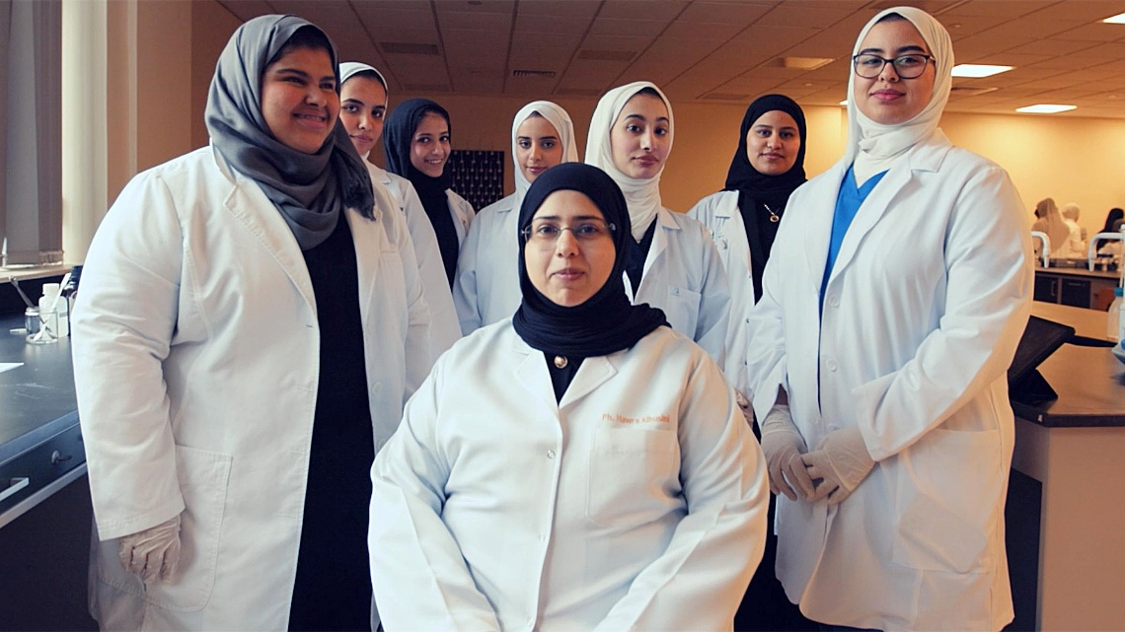

PAAET students are participating in applied learning assessments to evaluate sustainability literacy across disciplines.

Applied Competency in Academic Programs
Sustainability is integrated and evaluated within program-specific assessments across PAAET’s colleges:
- Engineering and Technological Studies: Capstone projects are graded on the inclusion of environmental impact, renewable-energy use, and sustainable design.
- Health Sciences: Clinical practicums assess awareness of sustainable healthcare practices and social determinants of health.
- Business and Management: Students analyze case studies on ethical leadership, circular economy, and sustainable enterprise development.
These discipline-based evaluations ensure that sustainability literacy is not abstract but embedded in real-world applications.

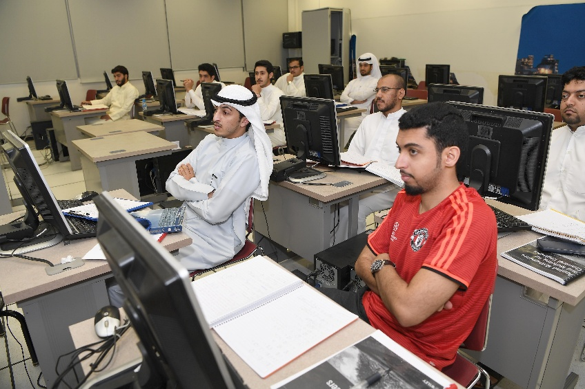

Students apply sustainable engineering principles in capstone projects focused on renewable energy and resource efficiency.

Graduate Tracer and Impact Studies
Beyond the classroom, PAAET conducts an annual Graduate Tracer Study that includes a sustainability module.
Graduates are surveyed on how effectively they apply sustainability concepts in their workplaces and communities.
This feedback provides longitudinal data to strengthen curricula and align education with Kuwait’s national sustainability priorities under Vision 2035.

Partnerships and Collaboration
PAAET’s approach to measuring sustainability literacy is supported through collaboration with:
- The United Nations Development Programme (UNDP) for SDG education alignment.
- The Kuwait Environment Public Authority (KEPA) for environmental awareness and data-based curriculum development.
- Regional universities and research networks contributing to best practices in sustainability education and assessment.
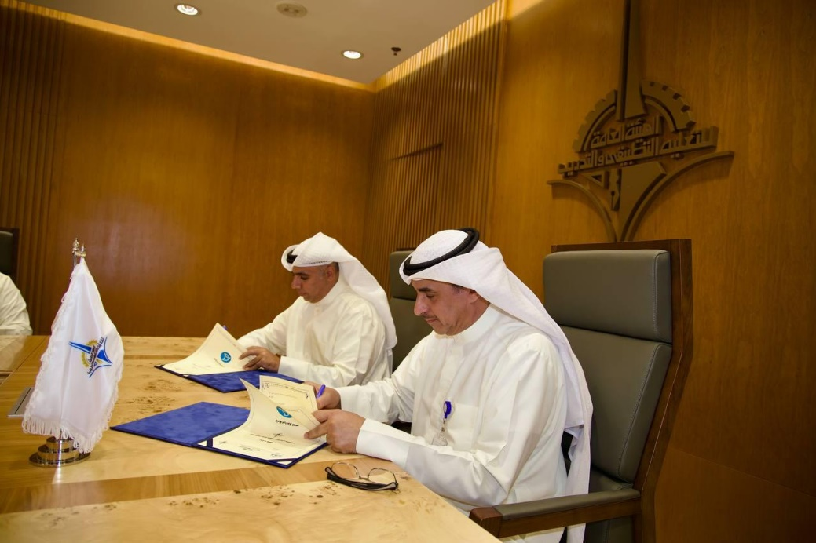

PAAET strengthens partnerships with national and international organizations to advance sustainability education and SDG alignment.

These partnerships ensure that PAAET’s literacy metrics align with international benchmarks and reflect Kuwait’s national sustainability agenda.

Continuous Improvement through Data
By linking course-level results, program evaluations, and graduate feedback, PAAET maintains a comprehensive evidence-based system to monitor educational outcomes.
This ensures that sustainability is not only taught, but its impact is quantified, refined, and reported transparently in line with global SDG monitoring standards.

Conclusion
PAAET’s systematic measurement of sustainability literacy reflects its strong institutional accountability and leadership in sustainability education.
Through direct assessment, applied learning, and long-term data tracking, PAAET ensures that every graduate is equipped to contribute meaningfully to Kuwait’s sustainable future and to the achievement of the UN 2030 Agenda.

