Commitment to Fairness and Employee Empowerment
At the Public Authority for Applied Education and Training (PAAET), our employees are the foundation of our success.
We are deeply committed to maintaining a workplace where every voice matters, where staff can freely raise concerns, and where every issue is handled with integrity, transparency, and respect.
This policy embodies PAAET’s dedication to decent work (SDG 8) and strong institutions (SDG 16) by embedding procedural fairness and human dignity across all employment levels.
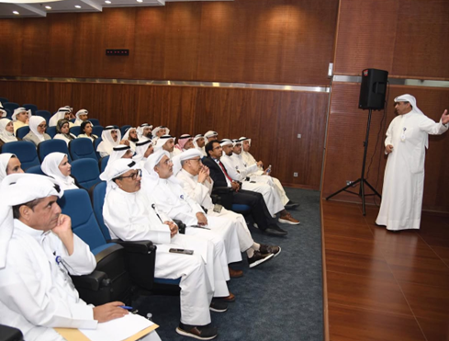

A friendly meeting between PAAET leadership, employees, and administration during an open discussion session focused on improving the workplace environment.

A Structured and Transparent Appeal System
PAAET’s grievance procedure is clear, accessible, and based on Kuwait’s national labor legislation.
It provides every employee with a fair path for resolution through three defined stages:
- Open Dialogue: Staff are encouraged to first seek an informal resolution by discussing their concern with their immediate supervisor.
- Formal Grievance: If the issue persists, a written grievance can be filed with the Human Resources Department, which conducts a formal review and provides a documented response within a set timeframe.
- Grievance Committee Review: Should further action be needed, the case is reviewed by an independent Grievance Committee composed of senior faculty and administrators to ensure impartial judgment and accountability.
This three-tier process ensures that every concern is handled objectively, confidentially, and with due process.

External Recourse and Legal Protection
PAAET’s commitment to justice extends beyond the institution. Employees retain the right to seek external recourse through:
- The Ministry of Social Affairs and Labor, which oversees labor law compliance; and
- The Kuwaiti Administrative Court, which reviews employment-related decisions and ensures fair judicial oversight.
This dual-layer system guarantees that PAAET’s governance is anchored in the rule of law and fully aligned with national justice principles.

Awareness and Continuous Improvement
To promote a culture of trust and empowerment, PAAET:
- Publishes grievance procedures in employee handbooks and digital HR platforms.
- Conducts training and orientation sessions on employee rights and ethical communication.
- Guarantees confidentiality for all complaints and prohibits retaliation.
- Regularly reviews grievance statistics to improve policy effectiveness.
These measures ensure that justice is not only available but actively practiced throughout the institution.
The PAAET Strategic Plan 2025–2030 strengthens this institutional framework by highlighting transparent governance and fair administrative processes as strategic priorities. It formalizes channels for consultation, performance evaluation, and feedback, ensuring that employee concerns are addressed efficiently and objectively. Through these mechanisms, the Authority embeds justice, accountability, and empowerment in its workplace culture—directly supporting SDG 8 targets on fair treatment and institutional trust.

Alignment with National and Global Standards
PAAET’s system reflects the International Labor Organization (ILO) grievance guidelines and meets Kuwait’s legislative requirements.
By linking internal resolution processes with external legal safeguards, PAAET has become a national model for transparency, equity, and institutional justice in higher education.
PAAET students won gold and silver medals in Kuwait’s National Skills Competition, reflecting the Authority’s success in fostering technical excellence and employability among youth (Source: KUNA News Agency).

Conclusion
Through its multi-layered grievance and appeal framework, the Public Authority for Applied Education and Training ensures that every employee can speak up confidently and receive a fair hearing.
This commitment to equity and accountability strengthens employee well-being, enhances organizational trust, and advances Kuwait’s progress toward SDG 8 and SDG 16, reinforcing PAAET’s role as a leader in ethical governance and public service.

