A College Without Walls
The Public Authority for Applied Education and Training (PAAET) has redefined the role of higher education in Kuwait by transforming its campuses into centers of lifelong learning and community empowerment.
Through a wide range of dedicated outreach programs, PAAET ensures that education, skills, and knowledge extend far beyond enrolled students, reaching alumni, local residents, and vulnerable populations across society.
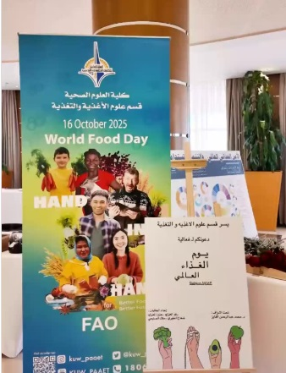
This mission embodies PAAET’s vision as a “civic university”, committed to building a skilled, informed, and inclusive society in support of the Sustainable Development Goals (SDGs).

PAAET’s College of Health Sciences partners with the FAO to celebrate World Food Day, raising awareness and building capacity in nutrition and sustainability.

Lifelong Learning for Alumni and the Public
At the heart of PAAET’s outreach is its Continuing Education Center (CEC), which offers non-credit short courses and workshops open to all community members.
The CEC’s catalog includes:
- Professional Upskilling: Project management, digital marketing, and data analysis.
- Life Skills Development: Financial literacy, cybersecurity awareness, and communication skills.
- Personal Enrichment: Foreign language and arts courses for personal growth.
These programs empower alumni and the public to continuously develop their capabilities, reinforcing SDG 4 – Quality Education and promoting lifelong learning.

Community Health and Civic Education
Through partnerships between the College of Health Sciences and the Office of Community Service, PAAET runs regular health awareness campaigns and free workshops in public spaces.
Topics include diabetes prevention, maternal health, nutrition, and mental well-being. Faculty and students also conduct first-aid and CPR training, enabling citizens to respond effectively in emergencies.
Complementary initiatives promote environmental stewardship and civic responsibility through road safety, waste management, and water conservation workshops, advancing SDGs 3, 6, and 12.

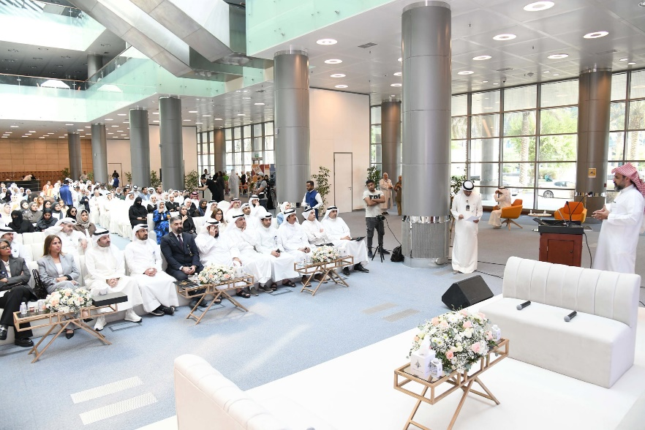

Faculty and community members participate in PAAET’s capacity-building lecture series, promoting knowledge exchange and professional development.

Inclusive Education for Vulnerable Populations
PAAET partners with local and international NGOs to deliver specialized educational programs for displaced and vulnerable communities.
These initiatives include:
- Arabic Language Courses – Supporting social integration and access to essential services.
- Vocational Training Workshops – Equipping participants with employable skills such as sewing, IT basics, and handicrafts.
- Psychoeducational Support Sessions – Promoting mental health, resilience, and inclusion.
Through this humanitarian engagement, PAAET directly contributes to SDG 10 – Reduced Inequalities, ensuring that education becomes a pathway to empowerment for all.

A Holistic Approach to Community Engagement
PAAET’s outreach is built on a multi-tiered framework that connects education, health, and social inclusion.
Its programs are sustained through partnerships with ministries, NGOs, and alumni networks — ensuring broad accessibility and community relevance.
By leveraging its academic expertise for public benefit, PAAET fulfills its national mission while advancing SDG 17 – Partnerships for the Goals.
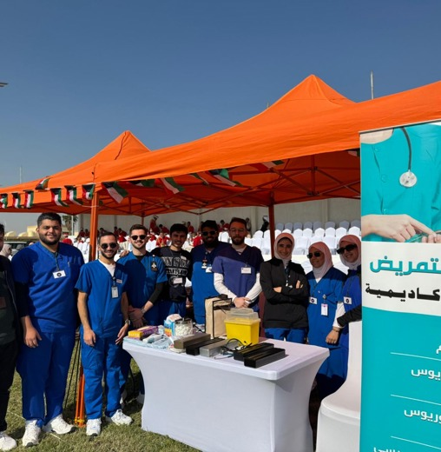

PAAET Nursing students participate in community health campaigns, developing applied skills and advancing sustainable healthcare education.

Looking Forward
PAAET continues to innovate its outreach model through initiatives such as:
- A digital community learning portal for free online courses and resources.
- A Community Advisory Board linking citizens and NGOs with PAAET’s outreach agenda.
- A micro-credentialing system offering recognized certificates for non-credit learners.
These steps reaffirm PAAET’s leadership in promoting accessible, equitable, and lifelong education across Kuwait and beyond.

Conclusion
Through its structured community outreach, the Public Authority for Applied Education and Training demonstrates that education is not confined to the classroom; it is a lifelong right and a shared national responsibility.
By empowering citizens, supporting vulnerable groups, and strengthening civic capacity, PAAET ensures that education remains the foundation of Kuwait’s sustainable future.

