Building an Institution of Fairness and Equality
At the Public Authority for Applied Education and Training (PAAET), fairness and equality are not only values but measurable practices that define our institutional culture.
We believe that equal pay for equal work is a fundamental right and a key driver of inclusive and sustainable growth.
As part of Kuwait’s national framework and commitment to the UN Sustainable Development Goals, PAAET ensures that every employee, regardless of gender, nationality, or background, receives equitable compensation and opportunities for advancement.

A Strong Foundation: Equal Pay for Equal Work
All PAAET employees are compensated according to Kuwait’s Unified Government Pay Scale, a transparent and objective system that determines salary based on:
- Job classification and responsibilities
- Educational qualifications
- Years of relevant experience
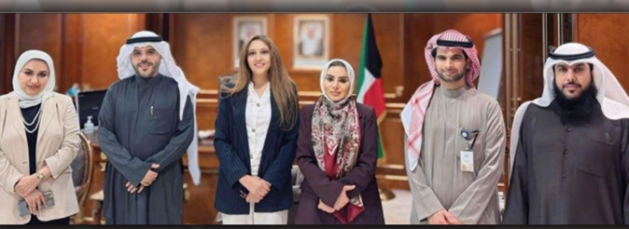
This unified structure ensures that men and women performing the same work receive identical pay, systematically eliminating gender-based wage disparities.

Faculty members from the Public Authority for Applied Education and Training (PAAET) met with the Minister of Social Affairs and the Minister of Family and Childhood Affairs.

Complementing this, PAAET’s Human Resources Policy explicitly prohibits discrimination in hiring, promotion, and compensation, reinforcing Kuwait’s constitutional principle of equality and fairness for all citizens and residents.
In alignment with Kuwait’s Civil Service Commission framework, the PAAET Strategic Plan 2025–2030 promotes fairness and gender balance through policies supporting equal opportunity and professional advancement. The plan emphasizes building national human capital and ensuring transparent employment structures that reward merit, qualifications, and experience rather than gender or background. These institutional commitments ensure continued compliance with national pay frameworks while advancing measurable gender equity and inclusion under SDG 8.

Beyond Compliance: Closing the Gender Pay Gap
While Kuwait’s pay scale guarantees equal pay for identical roles, PAAET recognizes the importance of addressing the broader gender pay gap, the difference in overall average earnings between men and women across all levels.
To address this, PAAET is implementing a data-driven strategy that includes:
- Regular pay equity audits to measure institutional pay distribution by gender.
- Representation analysis to enhance the participation of women in senior academic and administrative roles.
- Targeted professional development programs, such as mentorship and leadership training for women.
Through these proactive steps, PAAET seeks not only to maintain equality but to advance gender balance and empowerment across all its campuses.

Strategic Alignment with Kuwait Vision 2035
These efforts directly support Kuwait Vision 2035 – “New Kuwait”, which emphasizes gender empowerment, human capital development, and economic inclusion as pillars of national progress.
By embedding gender-responsive practices into institutional planning, PAAET contributes to both SDG 5 (Gender Equality) and SDG 8 (Decent Work and Economic Growth), strengthening its role as a leader in sustainable human development within Kuwait’s public sector.

Our Commitment to Continuous Progress
PAAET’s next phase focuses on transforming pay equity from a structural guarantee into an evidence-based culture of equity, one that utilizes measurable data to promote fairness, inclusion, and professional growth.
Through ongoing evaluation, training, and gender representation analysis, PAAET continues to ensure that every employee, female or male, can grow, contribute, and thrive equally.

Conclusion
The Public Authority for Applied Education and Training stands as a national model for equitable pay and gender fairness.
By ensuring transparency in compensation and investing in women’s advancement, PAAET demonstrates that equality is not only a legal requirement but a strategic asset that fuels innovation, collaboration, and sustainable success.
Through this commitment, PAAET continues to lead by example, ensuring that workplace equity, opportunity, and dignity remain at the heart of Kuwait’s educational and economic transformation.

