Commitment to Equity and Respect
At the Public Authority for Applied Education and Training (PAAET), people are our greatest strength.
We are committed to creating a professional environment where every employee, regardless of background, feels respected, valued, and empowered.
Our commitment to fairness is not just a policy statement but a guiding principle that drives institutional excellence, innovation, and alignment with Kuwait Vision 2035 and the United Nations Sustainable Development Goals.
PAAET’s formal non-discrimination policy ensures that all staff and faculty, academic, administrative, or technical, are treated equitably throughout their professional journey, from recruitment to promotion and beyond.
This framework reinforces Kuwait’s national labor legislation and reflects our contribution to SDG 8: Decent Work and Economic Growth.

PAAET Strategic Plan 2023 – 2028
The Public Authority for Applied Education and Training (PAAET) is firmly committed to developing Kuwait’s human capital and cultivating a workplace grounded in competence, fairness, and accountability in alignment with Kuwait Vision 2035.
The five-year strategy outlines initiatives designed to enhance job quality, empower national professionals, and foster creativity and innovation within a safe and equitable work environment.
It also promotes a culture of integrity, professionalism, and equal opportunity across all educational and administrative sectors, demonstrating PAAET’s active contribution to the Sustainable Development Goals, particularly SDG 8: Decent Work and Economic Growth.
Source: “Future Makers” magazine, September 2024 issue, pp. 4–9.

Protected Grounds Under the Policy
PAAET’s non-discrimination policy explicitly prohibits bias or unequal treatment on the following grounds:
- Nationality and Origin: Equal rights, opportunities, and benefits for Kuwaiti and non-Kuwaiti employees.
- Religion and Belief: Respect for religious diversity and freedom of expression.
- Gender: Equal pay for equal work and gender-balanced advancement across roles.
- Age: Fair employment practices and career opportunities for all age groups.
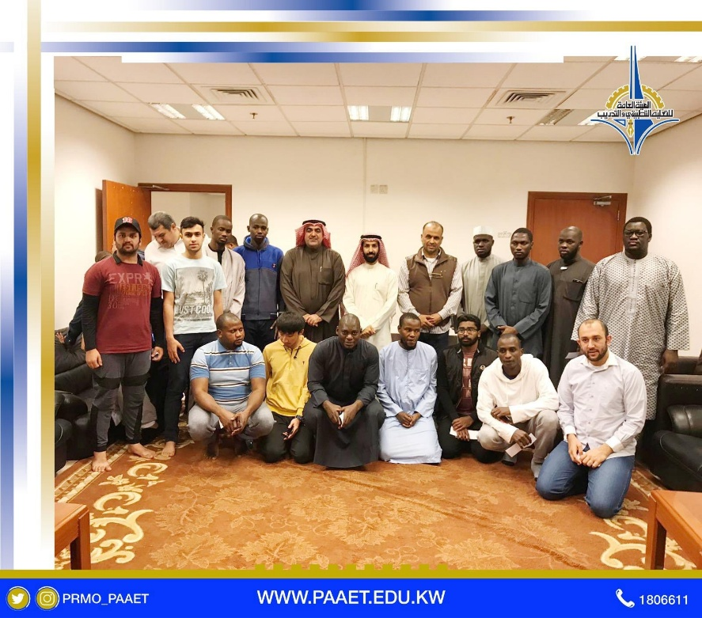

PAAET fosters inclusion and cross-cultural understanding through dedicated activities for international students, promoting equality and respect across all campuses.
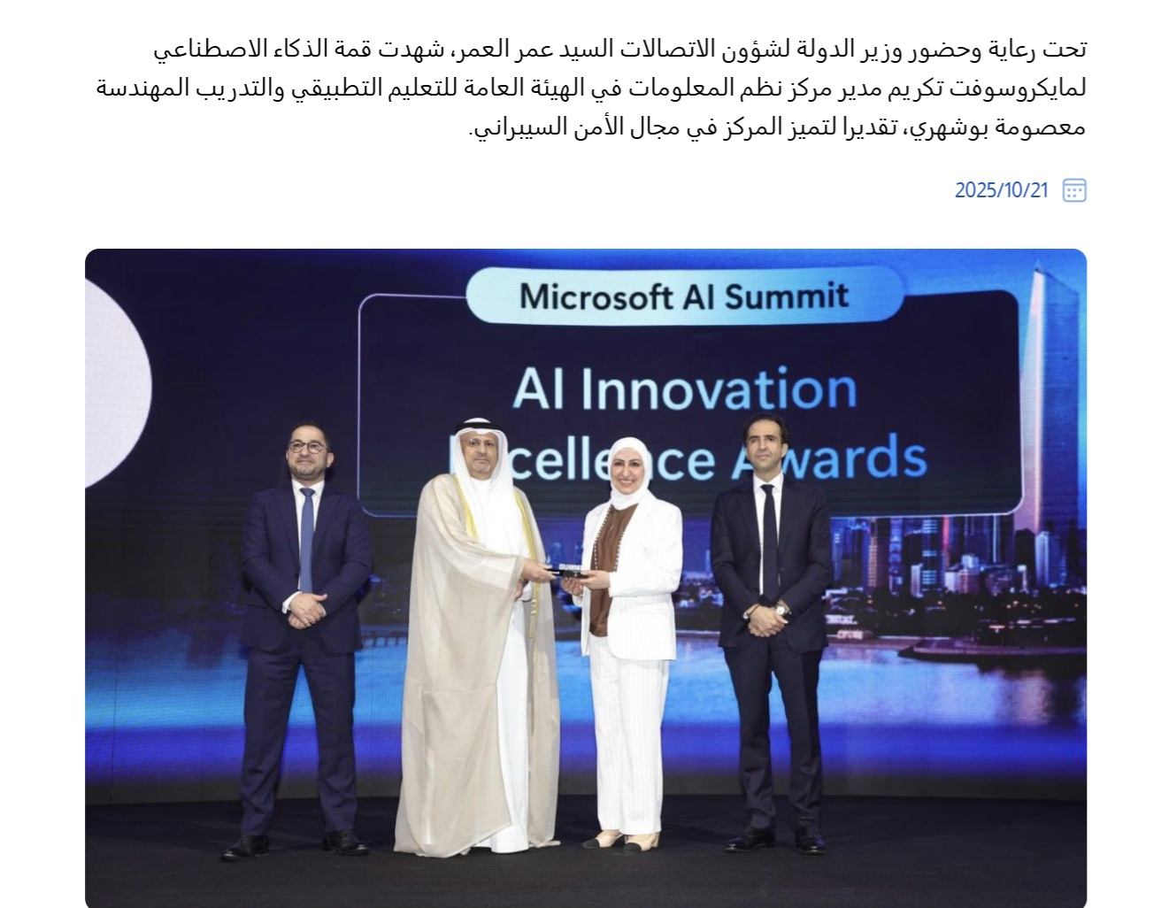

PAAET honors distinguished female faculty members, reinforcing its commitment to equality and inclusion in the workplace (SDG 8.2.3).

These protections are rooted in Kuwait’s Constitution and Labor Law No. 6 of 2010, both of which affirm justice, equality, and the right to dignified work for every individual.
PAAET’s commitment to equality and non-discrimination is grounded in Kuwait’s national legal framework and its adherence to international conventions. Articles 9, 10, 29, and 31 of Kuwait’s law emphasize training, public awareness, and technical cooperation to prevent exploitation and ensure respect for human rights. These principles are directly reflected in PAAET’s staff and student programs that promote inclusive education, bias awareness, and equal opportunity. Through workshops and capacity-building initiatives, PAAET operationalizes these national obligations, reinforcing a culture of fairness and equity across all campuses.

From Policy to Practice: Implementation and Enforcement
PAAET ensures that its commitment to equality is translated into tangible, enforceable action through several mechanisms:
- Integration in HR Processes: All recruitment, promotion, and evaluation procedures are merit-based, ensuring that skills and performance, not personal characteristics, determine advancement.
- Confidential Grievance System: Employees can report concerns privately and securely through the HR Department’s structured grievance channels.
- Protection from Retaliation: Whistleblowers are guaranteed confidentiality and immunity from any form of retaliation.
- Accountability and Discipline: Any confirmed violations trigger formal investigations and appropriate disciplinary measures, up to and including termination.
These mechanisms foster a culture of trust, ensuring that every staff member feels safe, supported, and fairly represented.

A Living Commitment to Inclusivity
Beyond compliance, PAAET views diversity as a source of strength.
To sustain a welcoming and inclusive work culture, the Authority is implementing several forward-looking initiatives:
- Mandatory Training on non-discrimination, unconscious bias, and respectful communication for all employees.
- Transparency and Reporting through annual workforce diversity and equity summaries.
- Collaboration with National Agencies such as the Civil Service Commission and the Ministry of Social Affairs and Labor to ensure alignment with Kuwait’s evolving labor standards.
- Inclusive Engagement Campaigns that celebrate multiculturalism and equal opportunity across the campus community.

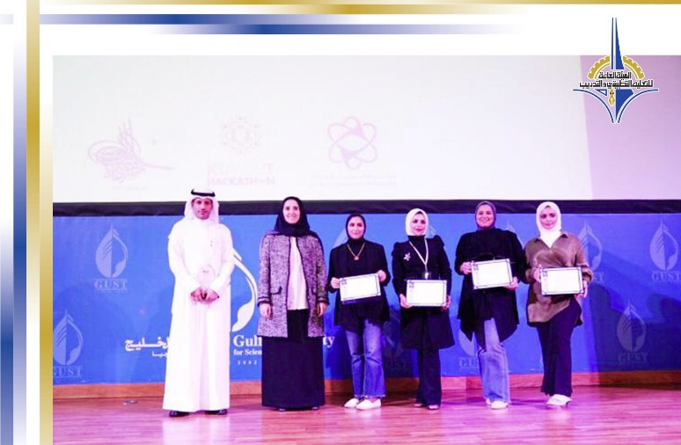

PAAET celebrates women’s achievements and contributions in education and innovation, reaffirming its commitment to gender equity and equal opportunities across all fields.

Through these programs, PAAET continues to lead by example as a responsible, inclusive, and progressive public institution.

Conclusion
The Public Authority for Applied Education and Training stands as a model of fairness, integrity, and equal opportunity.
Its non-discrimination policy, anchored in national law and international best practices, protects employees against bias based on gender, religion, nationality, or age, and promotes a workplace where diversity is celebrated.
By upholding these values, PAAET demonstrates its unwavering commitment to ethical employment, social justice, and sustainable human development, fully aligned with SDG 8: Decent Work and Economic Growth and Kuwait Vision 2035.

