From Global Knowledge to Local Solutions
The Public Authority for Applied Education and Training (PAAET) plays a pivotal role in transforming global experience into actionable, locally relevant best practices.
Through extensive international collaborations, comparative policy studies, and applied research, PAAET bridges global insights with Kuwait’s sustainable development agenda, ensuring that international strategies are effectively adapted to the Gulf context.
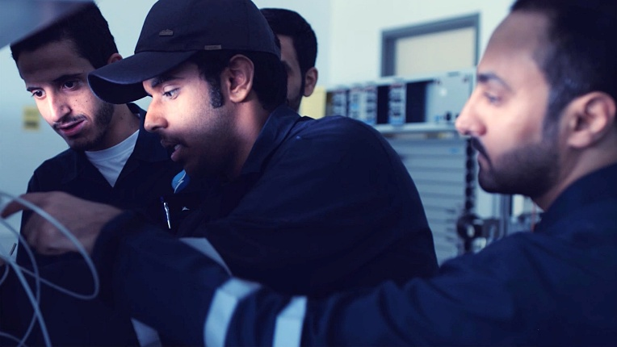

PAAET students engage in applied technical training, reflecting the institution’s commitment to global best-practice adaptation and capacity-building under SDG 17.

Between 2023 and 2024, over 150 faculty members and 300 students participated in comparative SDG projects with global partners.
By analyzing successful models worldwide and refining them to meet regional realities, PAAET serves as a hub of knowledge synthesis, contributing both to Kuwait Vision 2035 and to the global SDG dialogue.
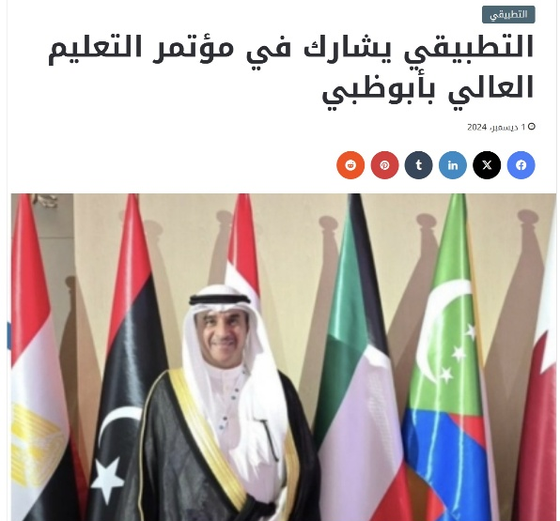

PAAET participates in the Arab Conference on Higher Education in Abu Dhabi, strengthening regional cooperation and knowledge exchange among Arab states in alignment with SDG 17.

Benchmarking and Reforming Applied Education (SDG 4)
PAAET collaborates with global organizations such as OECD and UNESCO-UNEVOC to benchmark Kuwait’s Technical and Vocational Education and Training (TVET) system against leading international models from Germany, Singapore, and Finland.
Through these comparative studies, PAAET developed a competency-based TVET framework that blends international standards with Kuwait’s cultural and economic priorities, creating a model for sustainable educational reform in the Gulf region.

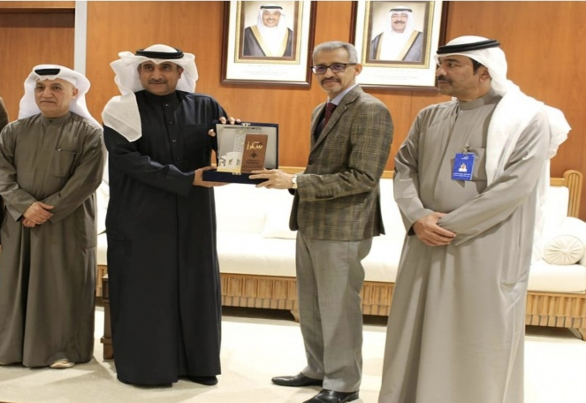

PAAET hosts the Director-General of ALECSO to strengthen cooperation in education, culture, and science across the Arab region, reinforcing Kuwait’s commitment to SDG 17 partnerships.

This initiative positions PAAET as a regional leader in applied education modernization, helping other institutions strengthen workforce readiness and bridge the gap between education and industry.

Advancing Public Health through International Learning (SDG 3)
PAAET works in close cooperation with Kuwait’s Ministry of Health, which partners with the World Health Organization (WHO) and leading international research institutions to advance public health initiatives.
Through this collaboration, PAAET contributed to analyzing global best practices for the prevention of non-communicable diseases (NCDs), drawing insights from successful national models such as Finland and Denmark.
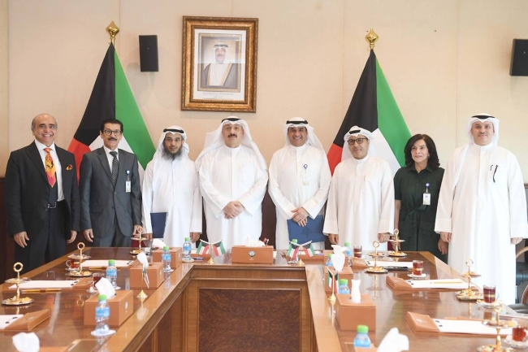

PAAET leadership meets with senior officials from the Ministry of Health to discuss avenues of cooperation in healthcare education, training, and research aimed at enhancing national capacity and community well-being.
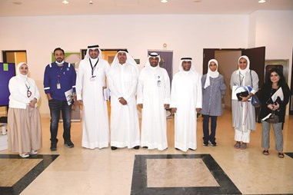

PAAET leadership meets with representatives from the Kuwait Oil Company (KOC) to discuss collaborative opportunities in technical training, applied research, and workforce development to support Kuwait’s energy sector.

These efforts supported the development of the GCC NCD Prevention Toolkit, a culturally adapted framework that integrates proven global approaches, including community-based screening and digital health promotion, tailored to the Arab Gulf context. By localizing global health strategies, PAAET supports evidence-based policymaking and strengthens community well-being across the region.

Engineering Sustainable Infrastructure for Arid Environments (SDGs 9 & 11)
PAAET’s College of Technological Studies leads an international consortium researching green building technologies and climate-resilient design for desert regions.
The consortium evaluates passive cooling systems, solar integration, and water-reclamation methods to determine the most efficient solutions for Kuwait’s unique environmental conditions.
Findings from this research are compiled into technical white papers and regional design guidelines, establishing new standards for sustainable construction and smart urban development in the GCC, and contributing valuable knowledge to the global community on sustainability in arid climates.

Transforming Research into Actionable Best Practice
PAAET’s global collaborations follow a clear and effective cycle:
- Review international strategies and data across education, health, and sustainability.
- Adapt these models through comparative analysis and pilot implementation in Kuwait.
- Develop best-practice frameworks and toolkits ready for replication across the Gulf region.
This approach ensures that knowledge is not only exchanged but co-created, generating new evidence-based solutions rooted in both global learning and local insight.
These initiatives are coordinated through the Office of Planning and Development and the Deputy Director-General for Academic Affairs and Innovation, ensuring systematic alignment with Kuwait Vision 2035 and national SDG priorities

Global Impact and Local Relevance
By synthesizing international knowledge into practical frameworks, PAAET contributes directly to the global repository of SDG best practices.
Its work has global recognition in reports and journals, including The Lancet, OECD reviews, and UNESCO case studies, demonstrating the university’s leadership in applied policy translation and research-driven reform.

Looking Ahead
To expand its global influence, PAAET plans to:
- Establish a Center for SDG Policy Translation, dedicated to scanning and adapting global innovations for local and regional application.
- Launch an SDG Best Practice Paper Series, publishing PAAET’s frameworks and toolkits in Arabic and English.
- Host an Annual Global SDG Summit, convening experts and policymakers to share and refine evidence-based practices for sustainable development in resource-rich and arid nations.

Conclusion
Through comparative research, innovation, and international collaboration, PAAET demonstrates that true progress on the SDGs depends on shared learning and practical adaptation.
By transforming global experience into tailored best practices, PAAET continues to lead Kuwait and the GCC toward a smarter, more sustainable future and contributes meaningfully to the world’s collective pursuit of the 2030 Agenda.

