Ethical Responsibility Beyond Direct Employment
The Public Authority for Applied Education and Training (PAAET) recognizes that its ethical and social responsibilities extend beyond its own employees to include the thousands of individuals who support its operations through contracted services such as security, cleaning, catering, and maintenance.
In alignment with Kuwait’s Labor Law No. 6 of 2010, the UN Sustainable Development Goals, and Kuwait Vision 2035, PAAET ensures that every worker, whether employed directly or through a third-party provider, enjoys fair treatment, dignity, and legal protection.

Vendor Code of Conduct: A Binding Ethical Standard
Every company that partners with PAAET must comply with the institution’s Vendor Code of Conduct, a legally binding document that enforces compliance with Kuwait’s labor regulations and international best practices.
This Code establishes minimum expectations across three key areas:
- Fair Wages and Legal Contracts. All vendors must guarantee lawful pay, prompt salary disbursement, and valid employment documentation.
- Safe and Respectful Working Conditions. Contractors are required to uphold occupational health and safety standards equivalent to those applied to PAAET’s direct employees.
- Prohibition of Exploitative Practices. Any form of coercion, passport confiscation, or delayed payment is strictly forbidden.
These principles extend the core values of equity, integrity, and justice throughout PAAET’s operational ecosystem.

Enforcement Through Contractual Accountability
To transform these ethical expectations into enforceable practice, PAAET’s Procurement and Contract Management Policy incorporates firm compliance mechanisms:
- Mandatory Labor Clauses – All service contracts include explicit language requiring compliance with Kuwait’s labor laws and verification of workers’ legal residency (Iqamas).
- Right to Audit – PAAET reserves the contractual right to inspect or request documentation, such as payroll records, to confirm that all workers’ rights are upheld.
- Corrective and Termination Measures – Vendors found in breach of the Code are subject to remediation plans or contract cancellation in cases of repeated non-compliance.
This “cascading accountability model” ensures that PAAET’s ethical obligations flow through every level of its supply chain.

Strengthening Oversight and Transparency
PAAET is continuously improving its procurement integrity through:
- Pre-qualification screening of contractors’ labor-rights performance before awarding contracts.
- Targeted audits for high-risk sectors such as facilities management and catering.
- Training programs for procurement and HR officers to identify, prevent, and address potential labor-rights risks.
- Collaboration with the Civil Service Commission and the Ministry of Social Affairs and Labor to ensure full legal compliance and policy alignment.
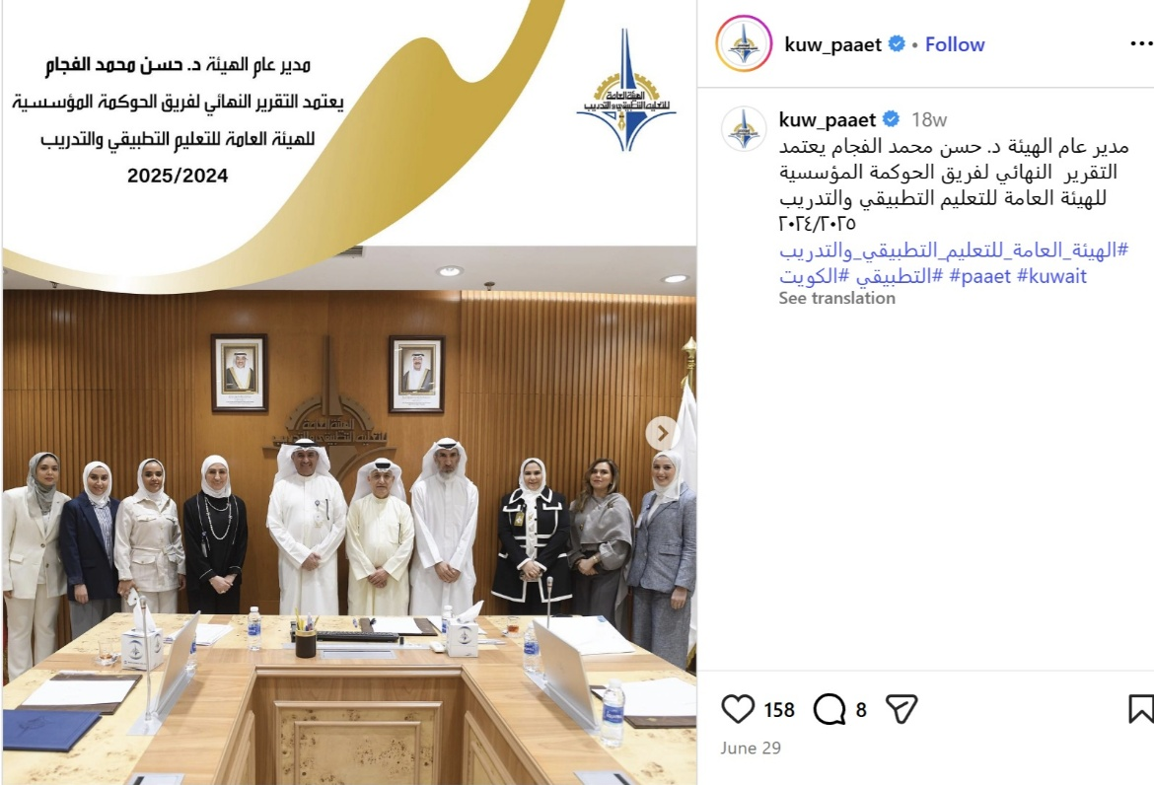

PAAET’s Director General approved the 2024–2025 Institutional Governance Team Report, reinforcing transparency, accountability, and good governance across the authority.

These measures enhance institutional transparency, accountability, and trust across the PAAET community.

A Model for Ethical and Inclusive Procurement
By embedding worker-protection requirements within all procurement processes, PAAET guarantees that outsourced staff enjoy equivalent rights and protections to those of directly employed personnel.
This approach transforms contracts into instruments of social responsibility and sustainable governance, promoting fairness and inclusion at every level of the institution.
Through these policies, PAAET affirms its leadership in ethical employment, advancing both SDG 8 – Decent Work and Economic Growth and SDG 16 – Peace, Justice, and Strong Institutions.

Conclusion
The Public Authority for Applied Education and Training safeguards the rights of every individual working within its campuses, whether as a direct employee or through a third-party partner.
By mandating fair contracts, enforcing compliance, and maintaining vigilant oversight, PAAET upholds human dignity, equality, and accountability across its operations.
This framework exemplifies responsible public-sector procurement in Kuwait and reinforces PAAET’s commitment to sustainable and ethical development.
This approach is further institutionalized through the PAAET Strategic Plan 2025–2030, which establishes governance and accountability systems emphasizing transparency, integrity, and ethical practice across all operations. The plan calls for strengthening regulatory frameworks, improving monitoring of service providers, and promoting a culture of fairness and responsibility in every sector of the Authority. These measures demonstrate PAAET’s long-term commitment to social responsibility, sustainability, and the protection of workers’ rights in line with SDG 8 and Kuwait Vision 2035.

